3-Minute Timed Writing-Speed
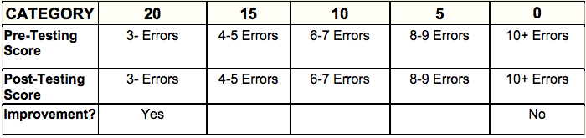

Total Points Earned ______________________

