A Snapshot on Aging and Dementia
Instructor’s Manual
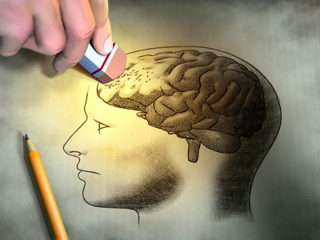
“Changing our minds about people whose minds have changed.” –G. Allen Power

The Texas Health and Human Services Quality Monitoring Program, dementia curriculum has been reviewed by the Alzheimer’s Association® and meets the Alzheimer’s Association Dementia Care Practice Recommendations in the following topics:
- Alzheimer’s and Dementia Disease Awareness
- Communications and Behaviors
- Strategies for Caring for the Person with Dementia
- Social Needs and Activities
Date of review completion: December 1, 2016
Review is applicable until: December 1, 2018
For more information go to www.alz.org

Table of Contents
Module 1……………………………………………………………………….Page 4-11
Ageism in America
History
Ageism in the American Culture
Reducing Ageism
Medical Professions in Aging

Module 2……………………………………………………………………….Page 12-17
The Brain
Brain Basics
Anatomy / Functions of the Brain
Virtual Brain Tour (Basics)
Brain Changes in Healthy Aging
Risks to Brain Health
Alzheimer’s Disease/Dementia:
Brain Changes in Alzheimer’s Disease / Dementia
Virtual Brain Tour (Alzheimer’s Disease and the Brain)
Most Common Types
Signs and Symptoms
Changes in Behavior

Module 3……………………………………………………………………….Page 18-20
How to care for someone with Alzheimer’s Disease / Dementia
Person-Centered Care
Alternate Therapies versus Medications
Art Therapy
Music Therapy
Reminiscence Therapy
Doll Therapy
Therapeutic Communication
Module 4……………………………………………………………………….Page 21-23
Intergenerational Programing

Appendices…………………………………………………………………….Page 24-62
Resources
Videos (Alive Inside, Still Alice, Glen Campbell)
Video Questionnaires
Web Links
Handouts
Activities, Quizzes (Answer Keys), Test (Answer Key)
Alternate Activities

Module 1:

Ageism in America

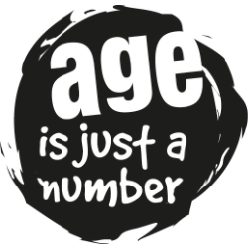

Section A: History

Objectives:

At the end of this section, your students will be able to:
- Define the term ageism
- Identify the population of individuals who are most likely to experience ageism.
- Identify stereotypes about older people

Before beginning your discussion on Ageism, turn to slide 4 and have your students watch the following video entitled “Mind the Gap” https://www.youtube.com/watch?v=RO1jlbTFhdk. You will want to stop the video at the 2:45 min mark.

Refer to slide 5 to present your students with the history of ageism

Slide 6 details Activity #1: Have students pair up and sit facing one another. Person A will repeat the word “old” over and over; person B will respond with any word that comes to mind. Allow students to do this for one minute, then switch roles and repeat the process for another minute. Close by reconvening the students; have volunteers report, first, things they found themselves saying (without repeating what their partners said) jotting these terms on the board; then have them notice the largely negative words and phrases that surface. Now have them pick the words and phrases that may sometimes be applied to older people. Circle the phrases, and relabel the column of words “Old people”. Ask the students to reflect on the following question: What does this show about how “being old” is valued in mainstream society?

Section B: Ageism in the American Culture

Objectives:

At the end of this section, your students will be able to:
- Identify why ageism is so prevalent in the American Culture

Refer to slide 7 to explain to your students why ageism exists in the American culture

Slide 8 shows the students the myths that often add to ageism and the facts about the myths.

Slide 9 explains to students how ageism can even be found in the way that we define what is “old” and what isn’t.

Slide 10 details Activity #2 Activity #2: Have students volunteer to present each of the following statistical findings, prepared on posters, about elders 65 years and older in the United States, prepared in separate poster format; for each one of the categories, ask students to think for a moment of the stereotypes in the category commonly applied to elders. As presenters finish, have them post signs in one part of the room.

Physical Health Poster:
Physical Health
• 4 out of 5 elders are healthy enough to do their normal activities. Only 5 percent of those 65 and over are institutionalized.
• While more persons over 65 have chronic illnesses that limit their activity than do younger persons, elders actually have fewer acute illnesses than do younger persons, have fewer injuries in the home, and fewer highway accidents than younger persons.
• The majority of persons past 65 continue to have both interest in and capacity for sexual relations, usually into the seventies and eighties for healthy couples.

Mental Health Poster:

Mental Health
• There is little or no decline in everyday short-term memory among normal elders. Less than 1 out of 5 elders have long-term memory losses and cannot remember such things as the past President of the United States; their correct age, birth date, telephone number, mother's maiden name, or address. The majority of elders do not have serious memory defects. Significant learning and memory problems are due to illness, not to age.
• Major depression is less prevalent among older adults than among younger people. However, of the various mental illnesses depression is one of the most common among the elderly. It has been estimated that from 30% to 60% of the elderly population experience at least one episode of depression severe enough to interfere with daily functioning. This, along with the fact that the rate of elderly suicide is the highest of all age groups, makes depression a significant issue.
• Most elders retain their normal mental abilities, including the ability to learn and remember. Reaction time tends to slow down in old age and it may take somewhat longer to learn new things. But much of the difference between older and younger persons can be explained by other things: illness, motivation, learning style, lack of practice, or amount of education. When these are taken into account, age does not influence learning ability.
• Mental illness is not common among elders. Only about 2 percent of persons 65 and over are institutionalized for psychiatric illness. Less than 10 percent have significant or severe mental illness, and another 10 to 32 percent have mild to moderate mental impairment; but the majority is without impairment. The rate of mental illness among the elderly is less than that of younger persons.

Work Poster:

Work
• The majority of older workers can work as effectively as younger workers.
• Studies of employed older people under actual working conditions generally show that they perform as well as, if not better than, younger workers on most measures.
• Consistency of output tends to increase with age, and older workers have less job turnover, fewer accidents, and less absenteeism than younger workers.

Social relationships Poster:

Social Relationships
The majority of elders are not socially isolated. About two-thirds live with their spouse or family. Only about 4 percent of elders are extremely isolated, and most of these have had lifelong histories of isolation.

Poverty Poster:

Poverty
In 1989 1 in 10 of the elderly had incomes below the poverty level and 27% were near the level. Certain groups of elderly experience very high rates of poverty. These include widowed elderly women (21%), African-American elders (31%), and African-American elder women, aged 72 or older living alone (64%).

Close this activity by having students reflect on the most surprising statistic, if any, and what this brings to mind about elders that they know. Have volunteers share their thoughts.

Section C: Reducing Ageism

Objectives:

At the end of this section, your students will be able to:
- Identify ways in which ageism in America can be reduced.

Refer to slide 11 to provide your students with the ways in which ageism can be reduced in America.

Slide 12 details Activity #3: Activity #3: This activity is titled “The Young and the Beautiful”. You will need the following materials:
• Fashion magazines with images of women and men
• Poster boards or butcher paper, tape and markers
Instructions:
1. Break your class into groups of 4 or 5 students.
2. The first task is, in five minutes time, have the students examine magazines and cut or tear out as many ad images of people under age 30 as they can find.
3. At the end of 5 minutes, stop. On butcher paper, have the students write down words to describe the images they have collected, answering the questions:
- What do the figures look like?
- What are they doing? Active, inactive?
- How can you tell that the models are under 30?
- What are the messages you can find, open or subtle, about “being young”?
- Any connections with the stereotype of “beautiful people”?
4. Now, have the students return to the magazines and find and collect ad images of people who are depicted as “elder” roughly ages 55-60 and older.
5. At the end of 5 minutes, have the students stop and discuss the following questions:
- Is it harder to find ads depicting older people? Why?
- If you found fewer ads, what is the implied messages about “being older”?
- What do the figures look like?
- What are they doing? Active, inactive?
- How many of the ads are explicitly about being older, e.g. medications, retirement plans, etc.? How many are about fashionable clothes? What is the difference?
- Any connections with the stereotype of “beautiful people”?
- Thinking about how adults and elders are depicted, who are more likely to be shown in “normal” roles, in which their age is not a factor, and who are more likely to be shown in roles where their age is a factor?
- Finally, then how are elders made invisible in this process?
Prepare for a 5-minute formal presentation of your discussion:
• Two group members from each group will present their collages (one will explain the “elder”, while the other will explain the “adult”) and explain what they show

Section D: Medical Professions in Aging

Objectives:

At the end of this section, your students will be able to:
- List and describe at least 6 of the medical professions in aging

Refer to slide 13 to present your students with the different medical professions that are available to care for the aging.

Slide 14 details Activity #4: Read the following article where people share their experiences with ageism: Ageism in America http://www.nbcnews.com/id/5868712/ns/health-aging. As you read, have the students complete the Facts and Opinions worksheet in Appendix A. Stop after a section of text in the article and have the students record the main facts in that section. Beside each fact, have the students record their opinions of it. After the entire article is read, have the students pair up and share their Facts and Opinions chart. Ask the students the following questions:
• Did you both pick out similar main facts?
• Were your opinions on each fact similar or different?

Slide 15 shows where you should stop for a Quiz.

Module 2:

The Brain

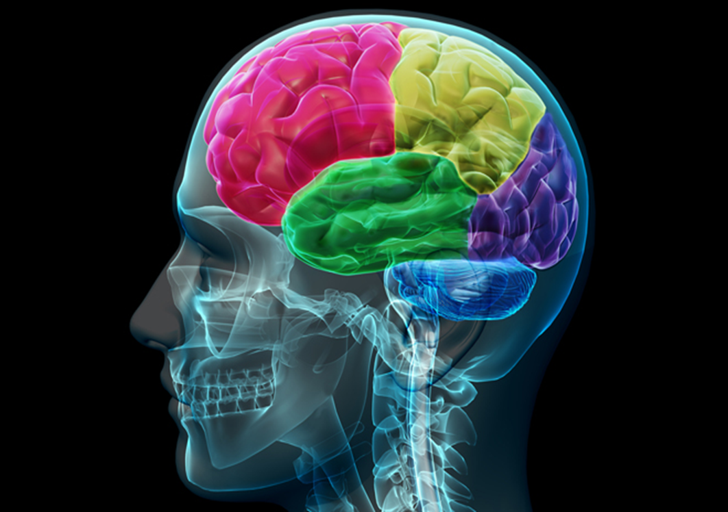

Section A: Brain Basics: Anatomy/Functions of the Brain

Objectives:

At the end of this section, your students will be able to:
- Identify five main (regions or five of the seven parts?)of the brain
- Identify the function of each of the lobes of the brain

Slide #17 provides information for Activity #1: Prior to beginning this section, have your students look at Appendix B for the Brain Parts and Regions of the Brain coloring and labeling sheets. You will want them to label and color these as you discuss them. The answers to the labels for each sheet are below:

Brain Parts:
1. Cerebrum | 2. Hypothalamus | 3. Pituitary Gland | 4. Brain Stem
5. Spinal Cord | 6. Cerebellum | 7. Pineal Gland

Brain Regions
1. Frontal Lobe | 2. Parietal Lobe | 3. Occipital Lobe
4. Temporal Lobe | 5. Limbic Lobe

Refer to slides 18-26 to present your students with the anatomy of the brain parts.

Slides 27-31 detail the information that your students need related to the different lobes found in the cerebrum of the brain.

Read slide 32 which details the food and oxygen supply to the brain.

Activity # 2: Slide 33 contains the link that you will want to use to access the Alzheimer’s Associations brain tour. Here you will only click through the first 7 slides that show the basics of the brain.

Section B: Brain Basics: Brain Changes in Healthy Aging

Objectives:

At the end of this section, your students will be able to:
- Identify the main changes that are seen in the brain with healthy aging.

Refer to slide 34 for the changes that are seen in the brain as a result of normal aging.

Section C: Brain Basics: Risks to Brain Health

Objectives:

At the end of this section, your students will be able to:
- List 5 of the major risk factors to an individual’s brain health.

Refer to slide 35 for the risk factors to brain health.

Section D: Alzheimer’s Disease and Dementia

Objectives:

At the end of this section, your students will be able to:
- Identify the definition of dementia

Refer to slide 36 which provides the definition of dementia as well as some facts about dementia worldwide.

Section E: The Most Common Types of Dementia

Objectives:

At the end of this section, your students will be able to:
- List the most common types of dementia and describe the percentage of individuals affected by them.

Refer to slide 37 which presents to your students the three most common types of dementia and the percentage of individuals typically affected by them.

Section F: Brain Changes in Alzheimer’s Disease and Dementia

Objectives:

At the end of this section, your students will be able to:
- Describe the changes seen in the three most common types of dementia.

Refer to slide 38 which presents the brain changes that are noted in the 3 most common types of dementia.

Activity # 3: Slide 39 contains the link that you will use to access the Alzheimer’s Associations brain tour. Here you will only click through the last 9 slides that show Alzheimer’s Disease and the brain.

Section G: Signs and Symptoms of the most common types of Dementia.

Objectives:

At the end of this section, your students will be able to:
- List the signs and symptoms of the three most common types of dementia

Refer to slide 40 which presents to the students the signs and symptoms that are seen in the most common types of dementia.

Section H: Stages of Alzheimer’s Disease.

Objectives:

At the end of this section, your students will be able to:
- Describe the three different stages of Alzheimer’s Disease

Refer to slide 41 which presents to the students the three different stages of Alzheimer’s Disease.

Section I: Changes in Behavior.

Objectives:

At the end of this section, your students will be able to:
- Identify the main reason for out of character behaviors in individuals with any form of dementia.
- List 5 of the behaviors often seen in these individuals.

Refer to slide 42 which will provide students with the information related to the changes in the behavior of individuals with some form of dementia.

Slide 43 explains to students how behavioral changes can increase the risks for negative situations that someone with dementia may experience.

Slide 44 has the link to a short video that provides a quick and easy explanation of what dementia is.

Slide 45 shows where you should give students a Quiz.

Module 3:

Caring for someone with Alzheimer’s Disease/Dementia

Section A: Person-Centered Care.

Objectives:

At the end of this section, your students will be able to:
- List at least 6 of the aspects of Person-Centered Care.

Refer to slide 47 which describes the definition of Person-Centered Care.

Slide 48 provides students with the aspects of Person-Centered Care

Activity #1 is shown on Slide 49. Have the students create an all about me poster no bigger than 11inches by 14 inches (the size of a legal sheet of paper) that must include all of the components found in the All about me handout found in their student manual Appendix C.

Slide 50 discusses with students strategies for providing care for those with Alzheimer’s Disease or dementia in the areas of personal care, nutrition, pain management, wandering, falls, and physical restraint-free care.

Section B: Alternative Therapies versus Medications.

Objectives:

At the end of this section, your students will be able to:
- Identify and describe the 4 different types of alternative therapies discussed

Refer to slide 52 details the two specific medications that are used to lessen the cognitive symptoms of Alzheimer’s disease/dementia

Slide 53 provides students with some of the different alternative therapies that are available to those affected by Alzheimer’s Disease/dementia.

Slides 54 and 55 provide students with information specific to the Music and Memory program and the affects that music has on an individual’s brain.

Section C: Therapeutic Communication.

Objectives:

At the end of this section, your students will be able to:
- List ways in which they can assist with communication in Alzheimer’s Disease/dementia

Refer to slide 56 provides students with an overview of therapeutic communication and some of the changes that may be seen in individuals diagnosed with Alzheimer’s Disease/dementia

Slide 57 details for students the ways in which they can assist with communication for these individuals.

Slide 58 indicates that it is time for a Quiz

Module 4:

Intergenerational Programs

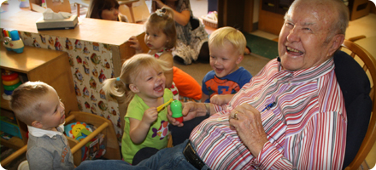

Section A: Why an Intergenerational Program.

Objectives:

At the end of this section, your students will be able to:
- Identify the importance of Intergenerational Programs.

Refer to slide 59 provides students with an n overview of what an intergenerational program is.

Slide 60 lists Activity #1 which should be given to the students prior to discussing this module. Have the students take their data match handout in Appendix D. They must partner with an older adult who is not a parent (can be a grandparent, aunt, uncle, etc.). They will bring their completed data match handout out to class on the day that you are going to teach this module and discuss their experience in visiting with the older adult and discussing the data in the worksheet. You should then have them discuss the similarities and differences that they had with the individual that they interview.

Slide 61 details for students the importance of an intergenerational program

Section B: Benefits of Intergenerational Programs.

Objectives:

At the end of this section, your students will be able to:
- Describe the benefits of an intergenerational program for the older adults, the youth, and the community.

Slide 62 provides students with the benefits of an intergenerational program for older adults

Slide 63 provides students with the benefits of an intergenerational program for the youth.

Activity #2 is described on Slide 64. Have your students make a list of the different volunteer opportunities that they are aware of using the attached volunteer opportunity worksheet in Appendix E. These can be through school, church, out in the community, etc. Discuss these different opportunities with the class.

Slide 65 provides students with the benefits of an intergenerational program for the community.

Section C: Examples of Intergenerational Programs.

Objectives:

At the end of this section, your students will be able to:
- Identify the three types Intergenerational Programs

Examples of intergenerational programs can be found on Slide 66.

Slides 67-69 will show videos that detail different types of intergenerational programs.

Slide 70 provides students with information related to advocacy of the older adults who may need assistance.

Slide 71 discusses with students the social needs and activities of those with a diagnosis of dementia

Slide 72 indicates that it is time for the students to take a test.

Appendices

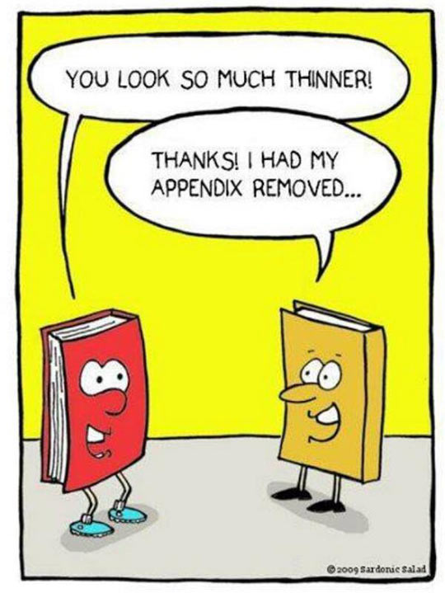

Appendix A:
Resources

Resources:

- Videos:
  - Alive Inside: a cinematic exploration of music’s capacity to reawaken our souls and uncover the deepest parts of our humanity. Filmmaker Michael Rossato-Bennett chronicles the astonishing experiences of individuals around the country who have been revitalized through the simple experience of listening to music. The documentary reveals the uniquely human connection that is found in music and how its healing power can triumph where prescription medication falls short. This documentary follows social worker Dan Cohen, founder of the nonprofit organization MUSIC & MEMORY℠, as he fights against a broken healthcare system to demonstrate music’s ability to combat memory loss and restore a deep sense of self to those suffering from it. Rossato-Bennett visits family members who have witnessed the miraculous effects of personalized music on their loved ones, and offers illuminating interviews with experts including renowned neurologist and best-selling author Oliver Sacks and musician Bobby McFerrin. The video is available to view on Netflix.
  - Still Alice: This movie tells the story of Alice Howland, a renowned linguistics professor who is happily married with three grown children. All that begins to change when she strangely starts to forget words and then more. When her doctor diagnoses her with Early-onset Alzheimer's Disease, Alice and her family's lives face a harrowing challenge as this terminal degenerative neurological ailment slowly progresses to an inevitable conclusion they all dread. Along the way, Alice struggles to not only to fight the inner decay, but to make the most of her remaining time to find the love and peace to make simply living worthwhile.
  - Glen Campbell I’ll Be Me: A documentary featuring Country singer Glen Campbell that follows the singer as he performs in his goodbye tour, after being diagnosed with Alzheimer’s Disease. The film documents this amazing journey as he and his family attempt to navigate the wildly unpredictable nature of Glen’s progressing disease using love, laughter and music as their medicine of choice.

- Web-Links:
  - Article on Ageism for Module 1 Activity #4: http://www.nbcnews.com/id/5868712/ns/health-aging
  - Alzheimer’s Association Brain Tour: Brain Basics (slides 1-7) - http://www.alz.org/braintour/3_main_parts.asp
  - Alzheimer’s Association Brain Tour: Alzheimer’s Disease and the Brain (slides 8-16) - http://www.alz.org/braintour/3_main_parts.asp
  - Module 1 Video: Mind Gap:
  - Dementia 101 in 101 Seconds: https://www.youtube.com/watch?v=_KlRpFu1Ub8
  - Module 4 Video: SKIP: https://www.youtube.com/watch?v=jp400M3xsn4
  - DOROT: Generations Helping Generations: https://www.youtube.com/watch?v=0PzzFpk4aZA
  - Brain Fit: An Intergenerational Program: https://www.youtube.com/watch?v=0etl28fcodo

Video Questionnaires Included Below (with Answer Keys):

Glen Campbell: I’ll be Me Movie
Activity Sheet
Answer the following questions after watching the movie I’ll Be Me:

- Where was Glen Campbell born and raised?
  - Texas
  - Arkansas
  - Tennessee
  - Oklahoma

- In what year was Glen Campbell diagnosed with Alzheimer’s Disease?
  - 2001
  - 2006
  - 2011
  - 2013

- What was the name of Glen Campbell’s final tour?
  - The Goodbye Tour
  - I’ll Be Me Tour
  - Rhinestone Cowboy Rides Away Tour
  - The Farewell Tour

- While at the doctor’s office, Glen’s doctor is explaining what to Glen about the structure of his brain?
______________________________________________________________________________________________________________________________________________________

- Music was a very important element that allowed Glen to retrieve memories that he otherwise was unable to remember. What effect does music have on your life?
________________________________________________________________________________________________________________________________________________________________________________________________________________________________________________________________________________________________

Glen Campbell: I’ll be Me Movie
Activity Sheet
Answer the following questions after watching the movie I’ll Be Me:

- Where was Glen Campbell born and raised?
  - Texas
  - Arkansas
  - Tennessee
  - Oklahoma

- In what year was Glen Campbell diagnosed with Alzheimer’s Disease?
  - 2001
  - 2006
  - 2011
  - 2013

- What was the name of Glen Campbell’s final tour?
  - The Goodbye Tour
  - I’ll Be Me Tour
  - Rhinestone Cowboy Rides Away Tour
  - The Farewell Tour

- While at the doctor’s office, Glen’s doctor is explaining what to Glen about the structure of his brain?
Glen’s doctor is describing to him how his hippocampus is the area of the brain that is vital for memory and that in Alzheimer’s disease it starts to shrink. He goes on to tell him that his is smaller than it used to be and that in all likelihood his difficulties are due to Alzheimer’s disease.
- Music was a very important element that allowed Glen to retrieve memories that he otherwise was unable to remember. What effect does music have on your life?
Answers will vary by student ________________________________________________________________________

Still Alice Movie
Activity Sheet
Answer the following questions after watching the movie Still Alice:

- In the movie Still Alice, the story is told from the perspective of a person suffering from which progressive disease?
  - Parkinson’s disease
  - ALS
  - Alzheimer’s disease
  - Multiple sclerosis

- What were the three words that Alice wrote down on the chalk board and repeated?
  - _____________________
  - _____________________
  - _____________________
- What was the one thing that Alice wanted to see her daughter Lydia do?
________________________________________________________________________________________________________________________________________________
- Alice says that she is no suffering, she is struggling. What is she struggling to do?
________________________________________________________________________________________________________________________________________________
- Alice says “So live in the moment I tell myself, it’s really all I can do, live in the moment”. What are some ways in which you “live in the moment”?
________________________________________________________________________________________________________________________________________________

Still Alice Movie
Activity Sheet
Answer the following questions after watching the movie Still Alice:

- In the movie Still Alice, the story is told from the perspective of a person suffering from which progressive disease?
  - Parkinson’s disease
  - ALS
  - Alzheimer’s disease
  - Multiple sclerosis

- What were the three words that Alice wrote down on the chalk board and repeated?
  - Hedgehog
  - Millennium
  - Stethoscope
- What was the one thing that Alice wanted to see her daughter Lydia do?
Alice really wants to see Lydia go to college instead of continuing to pursue her acting career.
- Alice says that she is no suffering, she is struggling. What is she struggling to do?
Alice says that she is struggling to be a part of things, to stay connected to who she once was.
- Alice says “So live in the moment I tell myself, it’s really all I can do, live in the moment”. What are some ways in which you “live in the moment”?
Answers will vary by student_______________________________________________ ________________________________________________________________________________________________________________________________________________

Appendix B:
Handouts

Ageism in America
Name: ______________________________ Date: ________________________________
Fact | Opinion
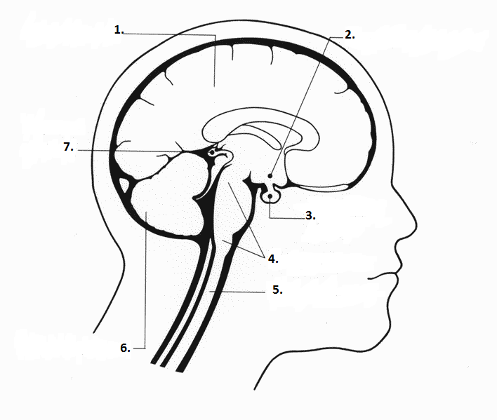

Label and color each part of the Brain:
1.__________________________________
2.__________________________________
3.__________________________________
4.__________________________________
5.__________________________________
6.__________________________________
7.__________________________________

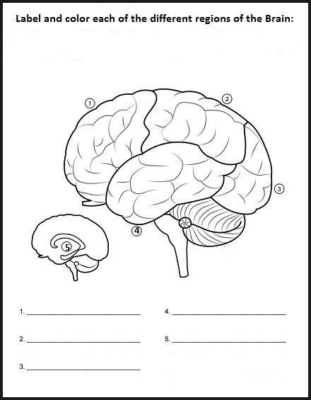

All About Me
Instructions:
You are to create a poster (no bigger than a legal size piece pf paper) that must include all of the following components:
- Name
- My best friends are
- Embarrassing stories my friends tell about me
- Things my friends love about me
- Favorite things
  - Band/Musical group
  - Teachers
  - Holidays
  - Music
- Important information about me
  - My age
  - Shoe size
  - Hair color
  - Nickname
  - Height
  - Favorite sport
  - Birthday
  - Favorite subject
  - Favorite food
- Best Day Ever
  - Where are you
  - Who are you with
  - What happens first
  - Next
  - Next
  - How does the day end
- Bad day
  - Where are you
  - Who are you with
  - What happens
  - How does the day end
- Important birthdays
- When I grow up
  - My dream house is
  - My dream job is
- Really, really annoying things
- Secret things (for our eyes only in very small letters)
Data Match Worksheet
Name: ________________________________ Date:_______________________
You |  | Older Adult
 | Favorite Color
 | Birth Month
 | Favorite Food
 | Number of Siblings
 | States you have lived in
 | Middle, Youngest, Oldest, Only Child
 | Has [# of] pets
 | Last movie watched in theatre
 | First name starts with which letter
 | Does/Does not have a driver’s license
 | Other topics for comparison (you chose the question/topic)
 | Other topics for comparison (you chose the question/topic)
 | Other topics for comparison (you chose the question/topic)

Name: ___________________________________ Date: ____________________
Volunteer Opportunity Worksheet
List as many volunteer opportunities that you know of (these can be opportunities in your school, church, community, etc.)
1.
2.
3.
4.
5.
6.
7.
8.
9.
10.
11.
12.
13.
14.
15.

Name:_____________________________________________ Date:______________________
Module 1 Quiz:
Complete the Sentence by finding the answer in the attached Word find puzzle

1. ______________ are experts in the nonmedical diagnosis of the auditory and balance systems
2. The term ________________ was coined in 1969 by Robert Neil Butler.
3. In this profession, the _____________________________ communicates and collaborates with the dentist to plan, design and fabricate dental prostheses for individual patients.
4. The largest population who are discriminated against, based on age, are the ________________.
5. Aging is viewed as counterproductive to the highly valued attributes of ______________, ____________, and _____________.
6. In many other countries, the elderly are still very much _________________.
7. There are many ______________ related to aging that are greatly perceived in the American culture.
8. One way in which you can help in reducing ageism is to ________________ the _______________.
9. A _________________________________ is an allopathic or osteopathic health care provider who is specifically trained to evaluate and manage the unique health care needs and treatment preferences of older people.
10. An individual that specializes in the prevention, diagnosis, and treatment of foot disorders, diseases, and injuries is known as a ___________________________.
11. A Social Worker helps people function as best they can, given the ________________ of their personal _______________ or _________________.
12. A Geriatric Psychiatrist specializes in the diagnosis and treatment of mental health issues that occur more commonly in older patients, such as ______________, _______________, ______________, late life addiction disorders, and ____________________
Name:__Answer Key_________________________________ Date:______________________
Module 1 Quiz:
Complete the Sentence by finding the answer in the attached Word find puzzle

1. Audiologists are experts in the nonmedical diagnosis of the auditory and balance systems
2. The term Ageism was coined in 1969 by Robert Neil Butler.
3. In this profession, the Dental Lab Technician communicates and collaborates with the dentist to plan, design and fabricate dental prostheses for individual patients.
4. The largest population who are discriminated against, based on age, are the Elderly.
5. Aging is viewed as counterproductive to the highly valued attributes of Youth, Beauty, and Vitality.
6. In many other countries, the elderly are still very much Esteemed.
7. There are many Myths related to aging that are greatly perceived in the American culture.
8. One way in which you can help in reducing ageism is to Recognize the Stereotypes.
9. A Geriatrician is an allopathic or osteopathic health care provider who is specifically trained to evaluate and manage the unique health care needs and treatment preferences of older people.
10. An individual that specializes in the prevention, diagnosis, and treatment of foot disorders, diseases, and injuries is known as a Podiatrist.
11. A Social Worker helps people function as best they can, given the Challenges of their personal Situation or Environment.
12. A Geriatric Psychiatrist specializes in the diagnosis and treatment of mental health issues that occur more commonly in older patients, such as Dementia, Depression, Anxiety, late life addiction disorders, and Schizophrenia

Module 1 Quiz Part 2
Module 1 Quiz Part 2 Answer Key

Module 2 Quiz Questions

Down
1. accounts for approximately 4% of dementia cases
3. Responsible for the production and release of
hormones into the body
4. Pinecone shaped gland responsible for producing
melatonin
5. Often referred to as the little brain, it controls body
functions such as balance, posture and coordination,
6. this lobe controls visual and auditory memories,
where speech and hearing capabilities are managed
9. Controls mood, thirst, hunger, and temperature and
contains the glands which control the hormonal
processes in your body
10. the main pathway for the information connecting
your brain and your peripheral nervouse system
11. the estimated cost of dementia worldwide is
anticipated to rise to this amount
13. This lobe only has one function, that is vision
15. The biggest part of the brain, making up 85% of
the brain's weight
Across
1. a general term for a group of symptoms that
describe one's decline in mental stability that is severe
enough to interfere with daily life
2. the most common types of dementia all begin with
this change
6. vascular dementia accounts for approximately this
percentage of cases
7. this lobe controls elements such as though, problem
solving, intellect, judgement, behavior, attention, and
many others
8. the most common type of dementia
12. this is reduced to the brain in normal aging
14. Lobe of the brain that focuses on concentration as
well as language, reading, tactile sensation, internal
stimuli, and sensory comprehension
16. include diabetes, obesity, high blood-pressure,
smoking, alcoholism, high cholesterol, head injuries,
and depression
17. houses smaller structures that are involved in
many pf your emotions and motivations, particularly
those related to survival
18. All of the basic life functions begin here

Module 2 Quiz Answer Key
Name:_____________________________________________ Date:______________________
Module 3 Quiz:
Complete the Sentence
1. ______________ is a care concept where the importance is on keeping the person at the center of their care.
2. ______________ and ____________ are medications used to lessen the cognitive symptoms experienced by someone with Alzheimer's Disease or other dementia related condition.
3. Alternative Therapies better known as ___________________ therapies are the best to use in situations when behaviors are displayed in those with some form of dementia.
4. ______________ is known to open up both cognition and communication that was otherwise thought to be lost in those with Alzheimer’s Disease or other dementia related condition.
5. ______________ is a therapy in which the main goal is to ensure personalization.
6. Individuals who suffer from Alzheimer's Disease or other form of dementia are able to re-capture the emotions that were associated to memories in _____________________________
7. In __________________, participants are able to provide love and affection to an object that is perceived to be real.
8. _____________________________ is the face-to-face process of interacting that focuses on advancing the physical and emotional well-being of an individual.
9. Being ________________ and _______________ shows a person that you are listening to and trying to understand them.
10. Because individuals with Alzheimer’s Disease or other forms of dementia may have decreased cognition, they may incorrectly say ______________ things.
11. When communicating with someone who has Alzheimer’s Disease or other form of dementia, you always want to focus on the ___________ and not the _____________ in the communication.
12. Put simply, person-centered care is about focusing on the needs of the ______________ rather than the needs of the ___________________.
13. In person-centered care, those providing care must ___________ listen and ____________ to be able to adapt to each individual’s changing needs, regardless of their _____________ or ___________.
Name:_ANSWER KEY_______________________________ Date:______________________
Module 3 Quiz:
Complete the Sentence

1. Person-centered care is a care concept where the importance is on keeping the person at the center of their care.
2. Namenda and Aricept are medications used to lessen the cognitive symptoms experienced by someone with Alzheimer's Disease or other dementia related condition.
3. Alternative Therapies better known as non-pharmacological therapies are the best to use in situations when behaviors are displayed in those with some form of dementia.
4. Art Therapy is known to open up both cognition and communication that was otherwise thought to be lost in those with Alzheimer’s Disease or other dementia related condition.
5. Music is a therapy in which the main goal is to ensure personalization.
6. Individuals who suffer from Alzheimer's Disease or other form of dementia are able to re-capture the emotions that were associated to memories in Reminiscence Therapy.
7. In doll therapy, participants are able to provide love and affection to an object that is perceived to be real.
8. Therapeutic Communication is the face-to-face process of interacting that focuses on advancing the physical and emotional well-being of an individual.
9. Be patient and supportive to show a person that you are listening to and trying to understand them.
10. Because individuals with Alzheimer’s Disease or other forms of dementia may have decreased cognition, they may incorrectly say normal things.
11. When communicating with someone who has Alzheimer’s Disease or other form of dementia, you always want to focus on the feelings and not the facts in the communication.
12. Put simply, person-centered care is about focusing on the needs of the person rather than the needs of the service.
13. In person-centered care, those providing care must actively listen and observe to be able to adapt to each individual’s changing needs, regardless of their condition or disease process.
Name:_____________________________________________ Date:______________________
Exam:
Directions: Select the best answer from the choices given

- Ageism was originally coined in _______ by ____________
  - 1960; Robert Neil Butler
  - 1969; Carl Bernstein
  - 1940; James Kelly
  - 1969; Robert Neil Butler

- True or False: The younger population of people is most commonly discriminated against based on their age?
  - True
  - False

- True or False: The aging process is viewed as counter to the valued attributes of youth, beauty, and vitality?
  - True
  - False

- True or False: Elders are viewed as esteemed in America, whereas in other countries they are significantly discriminated against?
  - True
  - False

- Which sub-population accounts for individuals who are 85 years of age and older?
  - “young-old”
  - “old-old”
  - “old”
  - Elderly

- What is the name of the medical field that is dedicated to the care of older adults?
  - Gynecology
  - Pediatrics
  - Geriatrics
  - Orthopedic

- The largest part of the brain is known as the Cerebrum and has five distinct regions. The region that is responsible for vision is the ____________ lobe.
  - Frontal
  - Temporal
  - Parietal
  - Occipital

- The Cerebellum controls essential functions such as:
  - Breathing
  - Balance
  - Heart beat
  - Coordination
  - Both b and d

- True or False: Your Spinal Cord is the main pathway of information connecting your brain and your sympathetic nervous system.
  - True
  - False

- This is a pinecone shaped gland in the brain that is responsible for producing melatonin
  - Pituitary gland
  - Hypothalamus
  - Brain stem
  - Pineal gland

- Circle all that apply: The avoidable risks to your Brain’s health include:
  - Obesity
  - Ethnicity
  - Smoking
  - Alcoholism
  - Genetics
  - Head injuries

- Which of the following are types of dementia?
  - Alzheimer’s Disease
  - Vascular
  - Depression
  - Both a and b

- Alzheimer’s Disease is the most common type of dementia affecting approximately what percentage of those with dementia?
  - 90% - 95%
  - 60% - 80%
  - 40% -50%
  - None of the above

- The brain change seen in the most common types of dementia is
  - Plaques
  - Decreased blood flow
  - Shrinkage
  - Protein deposits

- A common sign of Alzheimer’s Disease is when a person has trouble remembering:
  - What they had for breakfast
  - Conversations
  - Names
  - All of the above

- True or False: When someone suffering from Alzheimer’s disease or other dementia related conditions has an out of character behavior, he/she is at a higher risk for abuse, neglect, or exploitation.
  - True
  - False

- Person-centered care is a care concept that recognizes an individual’s
  - Disease process
  - Personality
  - Medications
  - Ability to pay for care

- True or False: It is not important to practice Therapeutic Communication with someone who is unable to verbally communicate with you.
  - True
  - False

- Intergenerational Programs have benefits that affect:
  - Older adults
  - Youth
  - Community
  - All of the above

- True or False: Intergenerational program help to dispel age-related myths and stereotypes
  - True
  - False

Name:__ANSWER KEY______________________________ Date:______________________
Exam:
Directions: Select the best answer from the choices given

- Ageism was originally coined in _______ by ____________
  - 1960; Robert Neil Butler
  - 1969; Carl Bernstein
  - 1940; James Kelly
  - 1969; Robert Neil Butler

- True or False: The younger population of people is most commonly discriminated against based on their age?
  - True
  - False

- True or False: The aging process is viewed as counter to the valued attributes of youth, beauty, and vitality?
  - True
  - False

- True or False: Elders are viewed as esteemed in America, whereas in other countries they are significantly discriminated against?
  - True
  - False

- Which sub-population accounts for individuals who are 85 years of age and older?
  - “young-old”
  - “old-old”
  - “old”
  - Elderly

- What is the name of the medical field that is dedicated to the care of older adults?
  - Gynecology
  - Pediatrics
  - Geriatrics
  - Orthopedic

- The largest part of the brain is known as the Cerebrum and has five distinct regions. The region that is responsible for vision is the ____________ lobe.
  - Frontal
  - Temporal
  - Parietal
  - Occipital

- The Cerebellum controls essential functions such as:
  - Breathing
  - Balance
  - Heart beat
  - Coordination
  - Both b and d

- True or False: Your Spinal Cord is the main pathway of information connecting your brain and your sympathetic nervous system.
  - True
  - False

- This is a pinecone shaped gland in the brain that is responsible for producing melatonin
  - Pituitary gland
  - Hypothalamus
  - Brain stem
  - Pineal gland

- Circle all that apply: The avoidable risks to your Brain’s health include:
  - Obesity
  - Ethnicity
  - Smoking
  - Alcoholism
  - Genetics
  - Head injuries

- Which of the following are types of dementia?
  - Alzheimer’s disease
  - Vascular
  - Depression
  - Both a and b

- Alzheimer’s disease is the most common type of dementia affecting approximately what percentage of those with dementia?
  - 90% - 95%
  - 60% - 80%
  - 40% -50%
  - None of the above

- The brain change seen in the most common types of dementia is
  - Plaques
  - Decreased blood flow
  - Shrinkage
  - Protein deposits

- A common sign of Alzheimer’s disease is when a person has trouble remembering:
  - What they had for breakfast
  - Conversations
  - Names
  - All of the above

- True or False: When someone suffering from Alzheimer’s disease or other dementia related conditions has an out of character behavior, he/she is at a higher risk for abuse, neglect, or exploitation.
  - True
  - False

- Person-centered care is a care concept that recognizes an individual’s
  - Disease process
  - Personality
  - Medications
  - Ability to pay for care

- True or False: It is not important to practice Therapeutic Communication with someone who is unable to verbally communicate with you.
  - True
  - False

- Intergenerational Programs have benefits that affect:
  - Older adults
  - Youth
  - Community
  - All of the above

- True or False: Intergenerational program help to dispel age-related myths and stereotypes
  - True
  - False

Alternate Homework Activity
Alternate Homework Activity Answer Key

