Accrued Revenue and Expenses Activity Outline

Activity Outline 7.8.1:
- Have your students research the Internet for articles on an accrual accounting system, citing a minimum of 3 resources for their writing.

- Ask your students to write a 2 page summary of an accrual accounting system. In the summary, include these definitions:
  - accrued revenue
  - accrued interest income
  - reversing entry
  - accrued expenses
  - accrued interest expense

- You might also want to give your students a brief outline of what you want included in the summary.
- Definition of an Accrual Accounting System
- History of an Accrual Accounting System
- Cash vs. Accrual System of Accounting
      - Explanation of each system
      - Pros and Cons
- Why Use an Accrual Accounting System?
- Summary

Activity Outline 7.8.2:
- Demonstrate calculation of accrued interest:
Issued a 6 month note receivable on September 1, 2003 for $5,000, 15% interest rate
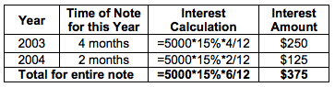

- Ask your students to create an Accrued Interest spreadsheet for calculating accrued interest.
- Have your students use the spreadsheet to provide answers for these accrued interest problems.
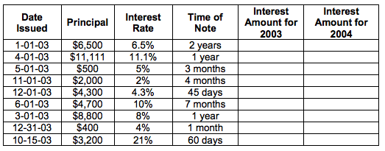

Activity Outline 7.8.3:
- Demonstrate the new accounts Interest Payable and Interest Receivable.
- Using an Accrued Entries presentation, demonstrate the adjusting, closing and reversing transactions for an accrual system of accounting with interest expense and income.
- Using an input form, analyze and journalize the transactions below:
- Adjusted Interest Expense for an 8 month note payable that was issued October 1, 2003. The principal was $6,700 at 7.9% interest rate.
- Prepared a closing entry for Interest Expense for the above account. There was no other balance in the account.
- Prepared the reversing entry for the letter above transaction.
- Paid cash for the above note on June 1, 2004.
- Adjusted Interest Income for a 45 day note received on December 1, 2003. The principal was $2,300 at 6% interest rate.
- Prepared a closing entry for the above transaction.
- Prepared an adjusting entry for the transaction in letter e.
- Received cash for the principal plus the note on January 15, 2004.

