Inductive Reactance - Answer Key Assignment #1

- XL = ω L or XL = 2π f L
- b
- Increase
- Increase
- a. XL = 2π f L = 6.28 x 60 Hz x .02 h = 7.54 Ω
  - XL = 2π f L = 6.28 x 400 hz x 0.025 h x 2 = 125.6 Ω
  - XLT = XL1 + XL2 = 25Ω + 25Ω = 50Ω
  - XL = 2π f L = 6.28 x 500000 Hz x 0.00001 h = 31.4 Ω

Answer Key Assignment #2

- a. True
  - True
  - True
  - False
  - False
  - True
  - True
  - False
 | ___________ | ______________ | ______
2. | Z = √ ( R )² + (XL)² = | √ (10Ω)2 + (10Ω)2 | = √200 = 14.14 Ω
 | ___________ | ___________ | _____
3. | VA = √ (ER)² + (EL)² = | √ (30)2 + (40)2 = | √ 2500 = | 50 | volts
Phase angle = ER / EA = 30/50 = .6 = 53º

- a. XL = 2π f L = 6.28 x 60 Hz x .1274 h = 48 Ω

___________ ______________
- Z = √ ( R )2 + (XL)2 = √ (20Ω)2 + (48Ω)2 = 52 Ω

- I = EA / Z = 130 volts / 52 Ω = 2.5 amperes

d. θ = tan-1 ( ^{X}_{R}^{L} ) = 67.38°

- VR = I R = 2.5 a x 20Ω = 50 volts

- VL = I XL = 2.5 a x 48Ω = 120 volt

Answer Key Assignment #3

1.
a. PT = I²R
b. PT = ERIR
c. PT = VI (PF) or El cos θ

2. a. PA – VI
b. PA = I²Z
c. PA = (V²) / Z

3. a. PX = 1²X
b. PX – VXIX
c. PX = VI sin θ

4. a. PF = PT / PA
b. PF = VR / VA
c. PF = R / Z

- Since there is no resistor, there is no true power. Therefore, answer is 0 watts.

- a. XL = 2π f L = 6.28 x 60 Hz x 0.5h = 188.4 Ω
___________ _________________
b. Z = √ ( R)2 + (XL)2 = √ (10Ω)2 + (188.4Ω)2 = 188.66 Ω

- I = VA / Z = 100 v / 188.66Ω = .53 amps

- VR = IR = 0.53 a x 10 Ω = 5.3 volts

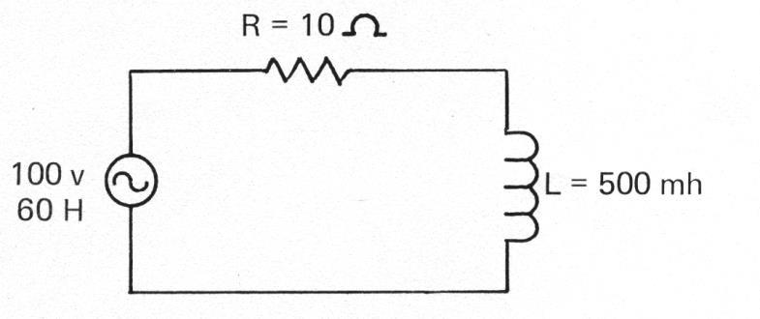
- VL = IXL = 0.53 a x 188.4 Ω = 99.85 volts

- PF = R / Z = 10 Ω / 188.66 Ω = 0.053

- PA = VI = 100v x .53 a = 53 volt-amperes

- PT = I²R = (0.53 a)2 x 10Ω = 2.81 watts

- PX = I²XL = (0.53)² x 188.4 Ω = 52.92 vars
Answer Key Assignment #4

- Q = XL / RS

- Lower

3. a. True b. True c. True d. False

- Q = XL / RS = 300 Ω / 0.5 Ω = 600

- Increases

- XL = 2π f L = 6.28 x 60 x 0.5h = 188.4 Ω
Q = XL / RS = 88.4 Ω / 0.5 ΩΩ = 376.8 or 377

Answer Key Assignment #5

- b

- a. 5

- 63.2%

- 86.5%

- 95%, 98%

- 36.8 %

- 13.5%, 5%

- a. I = V / R = 10 volts / ½ Ω = 20 amperes

  - TC = L/R = 0.5 h / 0.5 Ω = 1 second

  - 5TC = maximum current = 5 seconds

  - 19/20 = 95% = 3TC = 3 seconds

