Name: ____________________________Date: _____________________
Period____________

Assignment #1: The Engineering Problem Solving Process

PARTICPATION GRADE: (Place the following images into the correct order and paraphrase/put into your own words any missing information.)
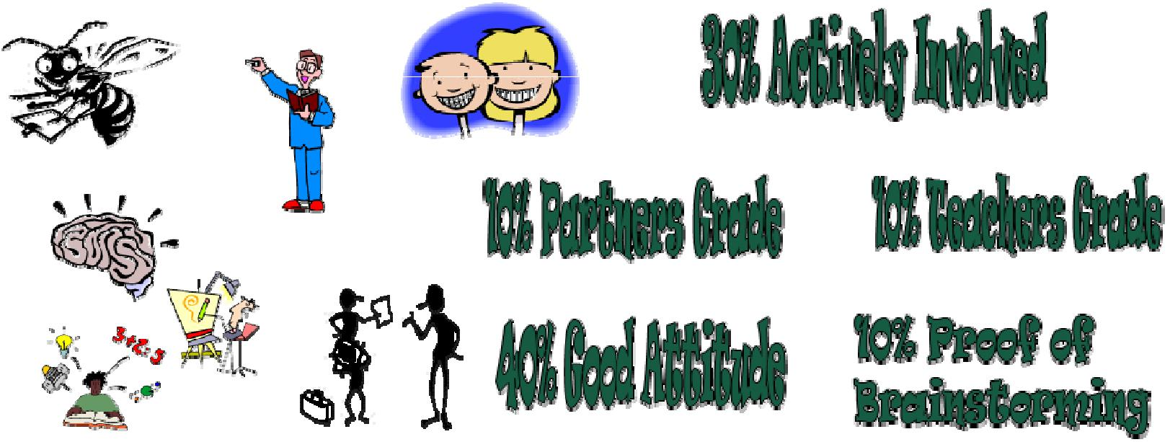

Percentage of grade for participation | Graphic that matches

TAALLS: The top 6 items your future employer wants you to know and do! (Type in what the rule is/means in the first column and find a graphic you feel best represents this rule to paste in the second column.)

TAALS stands for…. | Find a graphic from the internet
 | that you feel best matches this
 | rule and paste it here.

#1-T:

#2&3-AA:

#4-L:

#5&6-LS:

OSBORN’S RULES FOR BRAINSTORMING: (Find a graphic you feel best represents this rule and paste in the second column.)

Osborn’s Rules for Brainstorming | Find a graphic from the
 | internet that you feel best
matches this rule and paste
it here

1-Criticism is ruled out:

Judgment of idea is suspended until a later screening or evaluation
session.
Be positive!

2-Free-Wheeling is welcomed:

The wilder the ideas, the better! Even off- beat, impractical suggestions may trigger in other member’s suggestion which might not otherwise occur to them.

3- Quantity is wanted:

The greater the number of ideas, the greater likelihood of winners. It is easier to pare down a long list of ideas than puff up a short list.

4-Combination and Improvement are Sought:

In addition to contributing ideas of their own, panel members should suggest how suggestions by others can be turned into better ideas or how two or more ideas could be combined into a still better idea.

GOOD versus BAD Decision Making: Remember when making decisions and/or choices, we learn from others. We use their wisdom! We ask others their experience of or on a particular subject. Before we begin this process, we should look at the person (or better, persons).
We should get advice/learn from/someone…….
GOOD Decision Making | Opposite or BAD Decision Making
1- | 1-
2- | 2-
3- | 3-
4- | 4-
5- | 5-
6- | 6-
7- | 7-
8- | 8-

WHY is it important to make GOOD decisions and NOT the BAD ones? (Answer in 2-3 sentence paragraph please.)

