Name: ________________________________________________________Date:____________________
Period: __________________________Teacher:___________________________ Score: _________/100

Assignment #2: The Engineering Problem Solving Process

Assignment #2: Complete the following missing information by placing it in the correct column, area, etc.
Submit the finished.

You have one (1) day to solve the following three (3) puzzles and then use the information given in the solution to answer the following.

DR. GABIC Problem Solving Method Puzzle:
http://www.jigzone.com/puzzles/2614AB46535?m=8D250B75C2.8D4EEF8&z=6

Scientific Problem Solving Method Puzzle:
http://www.jigzone.com/puzzles/9214AB5ACD1?m=8D250B75C2.8D4EEF8&z=6

Closed Loop Universal System Model Puzzle:
http://www.jigzone.com/puzzles/BB14AB5AE0A?m=8D250B75C2.8D4EEF8&z=6

DR. GABIC: (Put the following images into the correct order and paraphrase/put into your own words any

missing information.) Puzzle Link =
http://www.jigzone.com/puzzles/2614AB46535?m=8D250B75C2.8D4EEF8&z=6
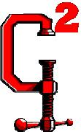
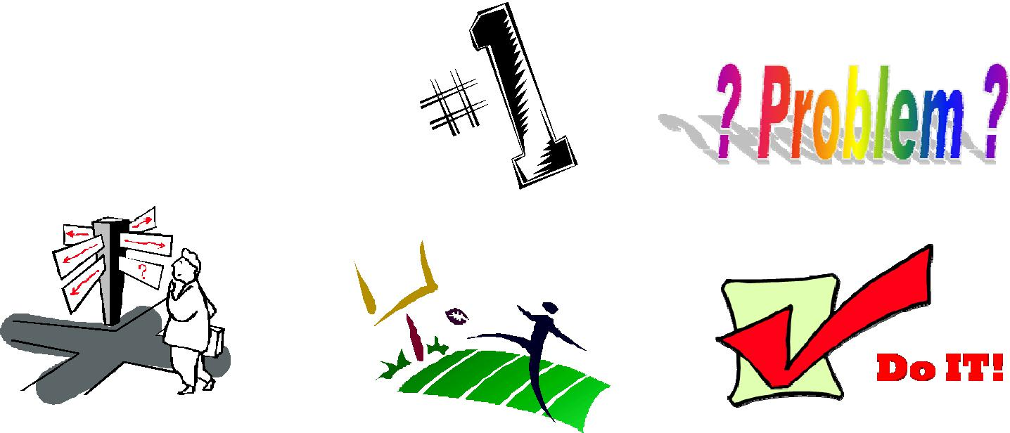

DR. GABIC Explained/Notes | Graphic that matches

D

RG

A

B

I

C2

Scientific Problem Solving: (Put the correct steps in each of the bubbles and complete the next page table.)

Puzzle Link = http://www.jigzone.com/puzzles/9214AB5ACD1?m=8D250B75C2.8D4EEF8&z=6
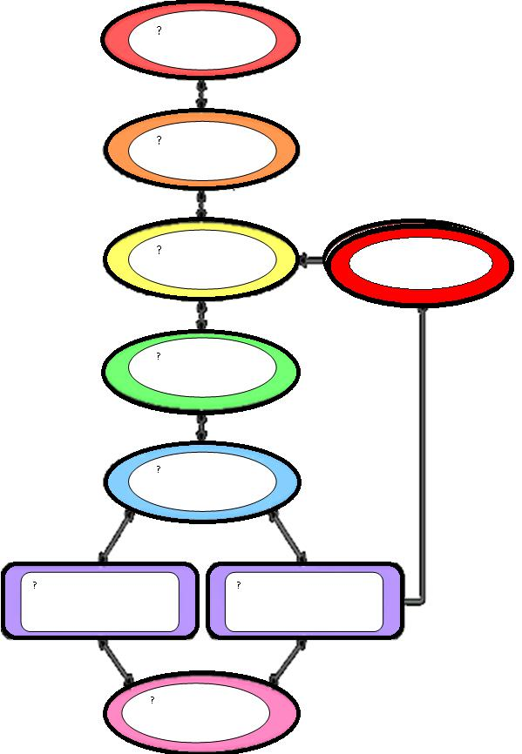

?

Find a graphic from the internet

Scientific Problem Solving Explained/Notes that you feel best matches this rule and paste it here.

STATE

FORM

TEST

COLLECT

ANALYZE

CONCLUSION

Compare and Contrast the two Problem Solving methods: (Put what you think in the space provided in the Table below.
 | DR. GABIC Engineering | Versus |  | Scientific Problem Solving
 | Problem Solving
 | How is it DIFFERENT than the | How are they the SAME |  | How is it DIFFERENT than “DR.
 | “SPS” |  |  | GABIC”
 |  | Step #1
 |  | Step #2
 |  | Step #3
 |  | Step #4
 |  | Step #5
 |  | Step #6
 | What are the two (2) most important | similarities between the two Problem |  | Solving Methods?
 | What are the two (2) most important differences between the two Problem Solving Methods?
 | In CONCLUSION what have you learned about these two (2) Problem Solving Methods?

Universal System Model & Problem Solving: (Put the correct steps in each of the bubbles and complete the next page table.) PUZZLE Link =
http://www.jigzone.com/puzzles/BB14AB5AE0A?m=8D250B75C2.8D4EEF8&z=6
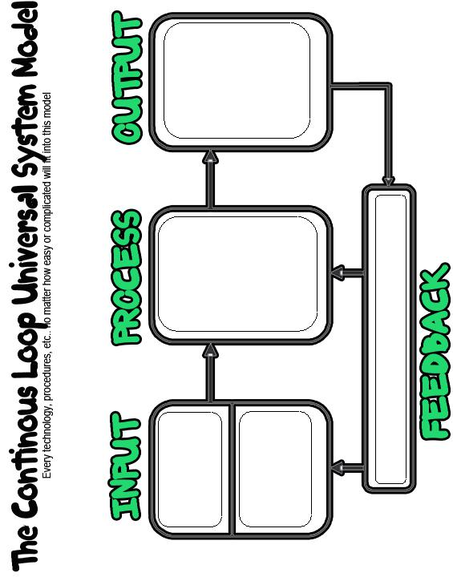

?

?

?

?

?

Universal System Model & Problem Solving: (Give an example of how the system works, for “I’m hungry and I want a peanut butter and jelly sandwich”.)
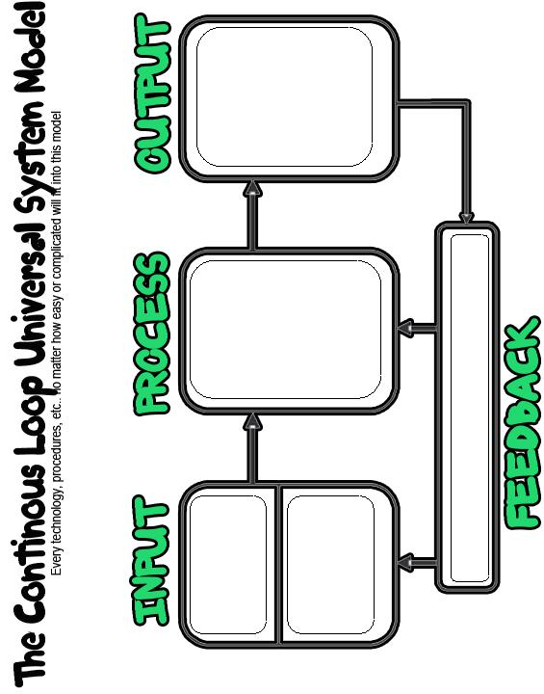

?

?

?

?

?

Universal System Model Continuous Loop Definitions (Type in what the rule is/means in the first column and find a graphic you feel best represents this rule to paste in the second column)
Universal System Model Continuous Loop Four (4) Steps | Find a graphic from the internet
 | that you feel best matches this
 | rule and paste it here.

#1-INPUT:

#2-PROCESS:

#3-OUTPUT:

#4-FEEDBACK:

Universal System Model Open Loop System: Can you find a graphic of this on the internet or explain in 2-3 sentences what you think this is?

