Basic Electricity and Electronics

Module One – Problem Worksheet Key

- A circuit has a 12 V power supply and a 1 kΩ resistor. What is the current?

I = V/R = 12V divided by 1000Ω= .012 A or 12 mA

- A circuit has a 42 kΩ resistor and 8 mA of current. What is the voltage?

V = I X R = .008 A X 42,000Ω = 336 V

- A circuit has 520 milli amps of current and 240 volts. What is the resistance?

R = V/I = 240V divided by .52A = 461.5Ω

- A circuit has 470 kΩ and 16 V. What is the current?

I = V/R = 16V divided by 470,000Ω = 0.000034 A = 34 μA

- I = 145 mA, R = 10 MΩ. V = ?

V = I x R = .145 A X 10,000,000Ω = 1.45 MV

- In the following circuit calculate current and voltage drops.

R₁ = 2 KΩ
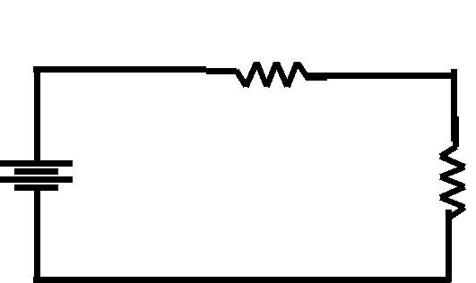

IT = 2 mA

V1 = 4V
V2 = 8V

R2 = 4 KΩ

VS =12V

- In the following circuit, calculate total current and total resistance.

 |  |  |  |  |  | R1 = |  | R2 = | IT = 13.5 mA
 |  |  |  |  |  |  |  |  | RT = 1333Ω
VS = |  |  |  |  |  | 2kΩ |  | 4kΩ
18V

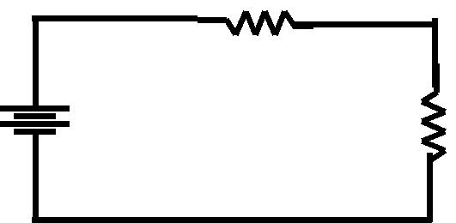
- In the following circuit, what is R₁? R1

R1 = 8 kΩ

R2 = 4 KΩ

VS = | I = 1 mA
12V

VS =

18V
- A power supply consumes 320 mW in order to supply 288 mW to the load. What is the efficiency?

Eff = power out divided by power in = 288/320 = .9 = 90%

10. What is R₂ in the following circuit?

I_{T} = 12 mA

R1 = | R2 = 6 kΩ
 | R2 = ?
2kΩ

