Basic Electricity and Electronics

Module One – Problem Worksheet

- A circuit has a 12 V power supply and a 1 kΩ resistor. What is the current?

- A circuit has a 42 kΩ resistor and 8 mA of current. What is the voltage?

- A circuit has 520 milli amps of current and 240 volts. What is the resistance?

- A circuit has 470 kΩ and 16 V. What is the current?

- I = 145 mA, R = 10 MΩ. V = ?

- In the following circuit calculate current and voltage drops.

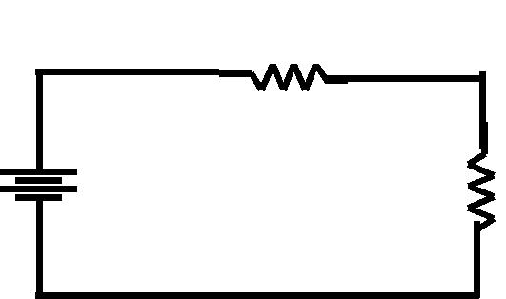
R₁ = 2 KΩ

R2 = 4 KΩ

VS =

12V

- In the following circuit, calculate total current and total resistance.

 | R1 = | R2 =
VS = | 2kΩ | 4kΩ
18V

- In the following circuit, what is R₁? R1
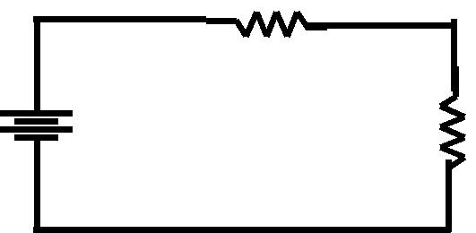

R2 = 4 KΩ

VS = | I = 1 mA
12V

- A power supply consumes 320 mW in order to supply 288 mW to the load. What is the efficiency?

- What is R₂ in the following circuit?

 |  |  |  |  | I_{T} = 12 mA
 |  |  |  |  |  | R1 = |  | R2 =?
VS = |  |  |  |  |  | 2kΩ
18V

