Basic Electricity and Electronics

Module One – Quiz

- Which device opposes current?
  - Resistor

  - Capacitor
  - Inductor
  - Coil

- Which of the following is a control device?
  - Resistor

  - Switch
  - Fuse
  - Ground

- What is the most common material a resistor is made from?
  - Silicon

  - Metal film
  - Carbon
  - Ceramics

- Which of the following is the symbol for current?
  - A

  - V
  - Ω
  - I

- How much resistance does an insulator have?
  - Zero

  - Some
  - A lot
  - Infinite

- Different elements always have different numbers of ___________?
  - Protons

  - Neutrons
  - Atoms
  - Atomic shells

- A volt is a/an:
  - Potential difference between two points

  - Unit of charge on an electron
  - Rate of flow of charge
  - Opposition to current flow

- How many forms of Ohm’s Law are there?
  - One

  - Two
  - Three
  - Four

- Energy is:
  - The fundamental ability to do work

  - The rate at which energy is used
  - The amount when one joule is used in one second
  - The maximum amount of power dissipated without damage

- A KW-Hr is a unit of:
  - Energy

  - Power
  - Heat
  - Voltage times current

- An electrical load is:
  - Any weight being carried

  - The amount of horsepower in a circuit
  - Any resistive element connected to a power supply
  - Taking more than four classes a semester

- Which of the following is a unit of power?
  - Joule

  - Joule per second
  - Joule-second
  - Volt-ohm

- When the voltage across a resister is doubled, the current will:
  - Triple

  - Halve
  - Double
  - Not change

- When the resistance in a circuit is doubled, the current will:
  - Triple

  - Halve
  - Double
  - Not change

- Sound is the movement of:
  - Air molecules

  - Electrons
  - Protons
  - Electricity

- A speaker acts similar to a:
  - Generator

  - Motor
  - Transistor
  - Battery

- What performs the work in an electric circuit?
  - Heat

  - Voltage
  - A resistor
  - Current

- What is the definition of current?
  - The movement of electrons

  - Force created by the buildup of charge
  - Force times distance
  - A twisting or rotary force

- What is the definition of voltage?
  - The movement of electrons

  - Force created by the buildup of charge
  - Force times distance
  - A twisting or rotary force

- What is resistance?
  - The interaction of two magnetic fields

  - Conversion of mechanical energy into electrical energy
  - An imbalance between electrons and protons
  - The opposition to current flow

- What is the formula for Ohm’s Law?

  - P = V I

  - I = V / R
  - F = M A
  - I = V² R

- CD data represents:

  - Signal frequency as a binary code

  - Signal amplitude as a binary code
  - Cosine transform coefficients
  - Data reduction through elimination of masked signals

- What is the sample rate of CD audio?

  - 20,000 samples/second

  - 128 Kbytes per second
  - 44,100 samples per second
  - 32 bits per second

- The unit of resistance is the:

  - Coulomb

  - Joule
  - Ampere
  - Ohm

- The unit of electrical charge is the:

  - Coulomb

  - Joule
  - Ampere
  - Ohm

- A circuit has a 12 V power supply and a 1 kΩ resistor. What is the current?

- A circuit has a 42 kΩ resistor and 8 mA of current. What is the voltage?

- A circuit has 520 milli amps of current and 240 volts. What is the resistance?

29. List some of the reasons electricity is so useful.

30. A circuit has 470 kΩ and 16 V. What is the current?

31. I = 145 mA, R = 10 MΩ. V = ?

- In the following circuit calculate current and voltage drops.

R₁ = 2 KΩ
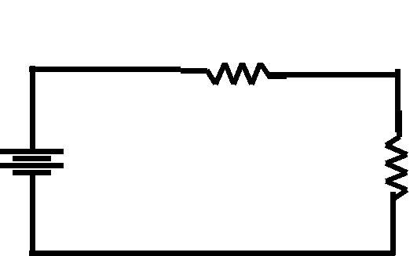

R2 = 4 KΩ

VS =

12V

33. In the following circuit, calculate total current and total resistance.

 | R1 = | R2 = 4kΩ
VS = | 2kΩ
18V

- In the following circuit, what is R₁? R₁
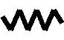
 |  |  |  |  |  |  |  |  |  |  |  | R2 = 4 KΩ
VS = |  |  |  |  | I = 1 mA
12V
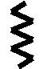

VS =

18V

- A power supply consumes 320 mW in order to supply 288 mW to the load. What is the efficiency?

36. What is R₂ in the following circuit?

I_{T} = 12 mA

R1 = | R2 = ?
2kΩ

