Basic Electronics – DC Magnetism Exam Key

Match the terms with their correct definitions.

1. | Magnetism | C | A The portion of a magnet where the magnetic lines appear to
 |  |  | converge or diverge
2. | Magnet | D | B A set of imaginary curved lines around a magnet that indicates the
 |  |  | strength and direction of the magnetic field
3. | Magnetic poles | A | C A property of certain materials, which exerts a mechanical force on
 |  |  | other magnetic materials, and that can cause induced voltages
 |  |  | in conductors when relative movement is present
4. | Magnetic lines | B | D An object that will attract iron, nickel, or cobalt, and that
 |  |  | will produce an external magnetic field

Match the terms with their correct definitions.

5. | Ferromagnetic | D | A A measure of the effectiveness of a material as a path for magnetic
 |  |  | lines of force as compared with the effectiveness of air
6. | Induction | C | B Non-magnetic materials with a permeability of less than one
7. | Permeability | A | C The process of magnetizing an object by bringing it into the magnetic
 |  |  | field of an electromagnet or permanent magnet
8. | Diamagnetic | B | D Magnetic materials with high values of permeability that range
 |  |  | from 50 to 5000

Match the inductance abbreviations with their correct definitions.

9. | Artificial magnet | C | A Any material found in the earth that exhibits the properties of
 |  |  | magnetism
10. | Permanent magnet | E | B The area around a magnet through which the lines of force flow
11. | Electromagnet | D | C A device that has been made magnetic by induction
12. | Magnetic field | B | D A core of soft iron that is temporarily magnetized by sending current
 |  |  | through a coil of wire wound around the core
13. | Natural magnet | A | E A magnetic device that retains its magnetism after it is removed
 |  |  | from a magnetic field

- Which of the following items is not a high permeability material?
A Iron

B Steel
C Cobalt
D Aluminum

- Which of the following items is not a low permeability material?
A Copper
B Zinc

C Cobalt
D Bismuth

- Which of the following items is not a medium permeability material?
A Copper

B Aluminum
C Manganese
D Chromium

- Which of the following items is a nonmagnetic material?
- Antimony
- Paper
- Alnico
- Iron

- Which of the following items is a high permeability material?
A Antimony
B Aluminum

C Alnico
D Zinc

- Select the true statement from the following concerning magnetic lines of force, magnetic fields, magnetic flux, and flux density.
A The direction of flow is from south to north pole
B Parallel lines going in opposite directions repel each other
C Magnetic lines of forces exert tension along their lengths, tending to lengthen themselves
D The magnetic lines of force are continuous and form complete loops

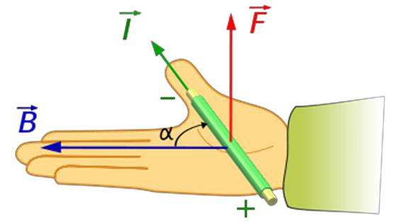

- In the figure above, the fingers point in the direction of
A Current flow
B The magnetic field

C The force on the conductor
D Magnetic induction

- Select the true statement from the following concerning Right-hand Rule of thumb for conductors in the figure below

A The thumb points in the direction of the current
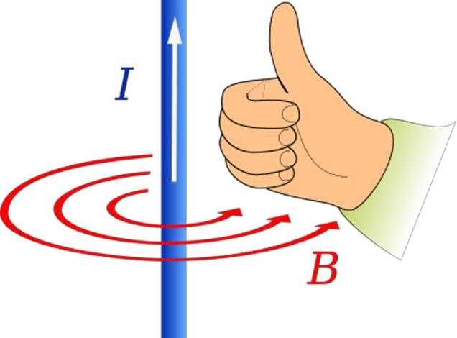
B The right hand holds the key to magnetism

C The thumb points in the direction of the force

D The magnetic lines of force are opposite the pointing fingers

- What creates magnetism?
A Electrical charge

B The right hand holds the key to magnetism
C Iron filings
D The dipole moment of an electron

- Which of the following is not a practical application of induction in the electronics field?
A Transformers

B Radio tuners

C The magnetic memory
D Motors and generators

- Which of the following are ways of producing artificial magnets?
  - Soldering and fabrication
  - Pounding and welding
  - Stroking and electrical coil
  - Wetting and wicking

- Which of the following is considered to be a natural magnet?
  - Lodestone
  - Electromagnet

  - Permanent magnet
  - Artificial magnet

- What is retentivity?
  - The ability to pass or conduct magnetic field lines
  - The degree which a material will become magnetized due to an external magnetic field
  - How long a magnet retains its magnetism
  - The strength of attraction of unlike poles

