Basic Lines Exam Key

Directions

Place the name of the type of line (identified in the diagram) in the spaces provided below.
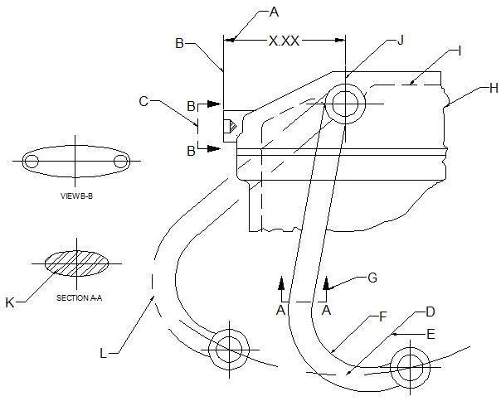

A. Dimension Line G. Cutting Plane Line
B. Extension Line H. Short-break Line
C. Cutting Plane Line I. Hidden Line
D. Center Line J. Center Line
E. Leader Line K. Section Line
F. Object Line L. Phantom Line

