Name ________________________________Date ____________________Class_______________

Basic Lines Exam
Directions

Place the name of the type of line (identified in the diagram) in the spaces provided below.
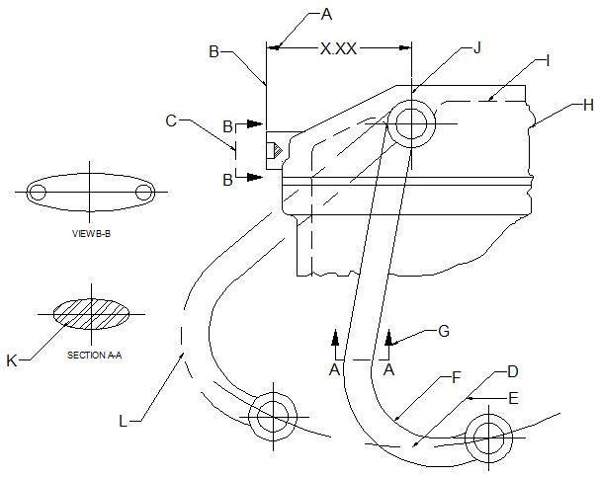

A. ______________________________ G. ______________________________
B. ______________________________ H. ______________________________
C. ______________________________ I. _______________________________
D. ______________________________ J. _______________________________
E. ______________________________ K. ______________________________
F. ______________________________ L. ______________________________

