Name ________________________________Date ____________________Class_______________

Basic Lines Worksheet 2 Key
Directions

Draw the type of line in the box provided that matches the description and purpose of the line.

Type of Line | Description | Purpose
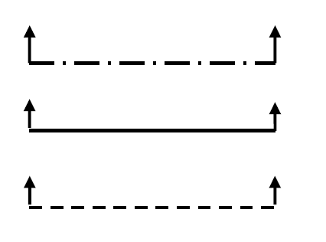 | The preferred cutting plane is a heavy, broken line made up of a series of one long and two short dashes alternately spaced. Arrowheads are placed at right angles to the cutting plane line as shown. Alternate cutting plane line is a solid heavy line on a series of long dashes. | To indicate where an imaginary cut is placed through the object. The arrow points in the direction in which the section should be viewed. Letters next to the arrowheads identify the section in cases where more than one section is shown on the drawing. These lines are oriented vertically, horizontally, or at the actual angle at which the part is drawn.
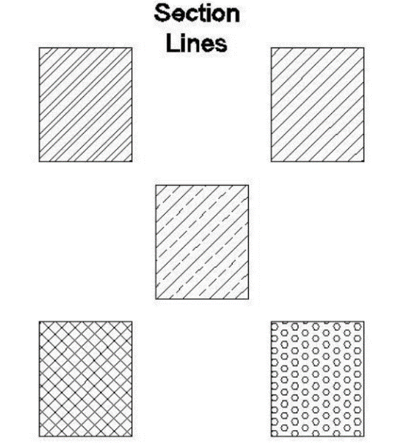 | Section line is a series of fine lines, solid or solid and broken, arranged in specific patterns. It may be shown either straight or curved. When shown straight, it is usually drawn at a 45-degree angle. However, this angle will vary when applied to adjacent parts. | To indicate the imaginary cut surface referred to by the cutting plane line; to represent various kinds of materials.

