Name_______________________________Date_____________________Class___________

**Basic Metal Shapes Handout 2 Key**

**Directions**

Write the correct name beside each of the following basic metal shapes.

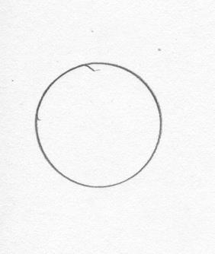

1. Round Bar

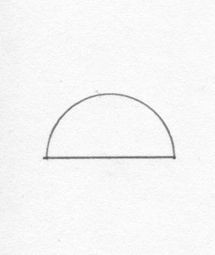

2. Half-Round Bar

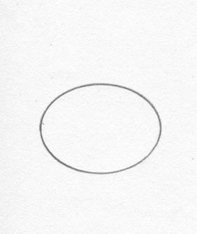

3. Oval Bar

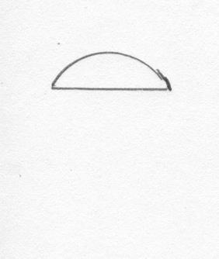

4. Half-Oval Bar

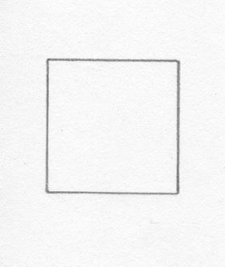

5. Square Bar

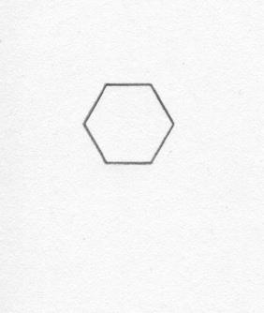

6. Hexagon Bar

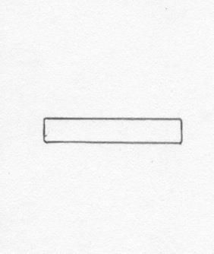

7. Flat Bar

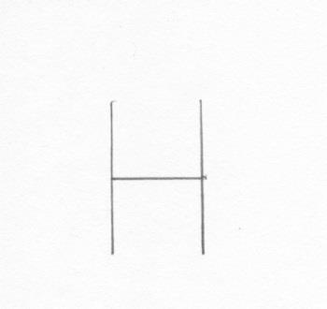

8. H-Beam

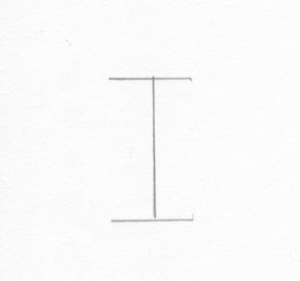

9. I-Beam

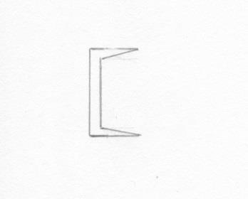



10. Channel

11. 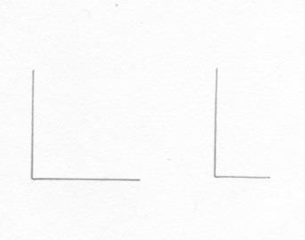 Angle

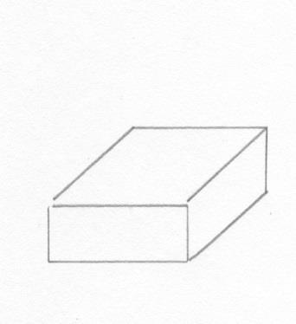

12. Flat Plate

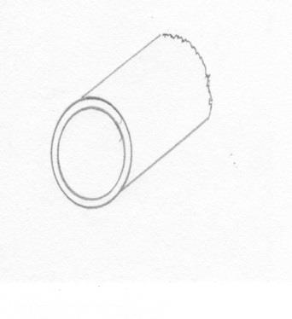

13. Pipe

14. 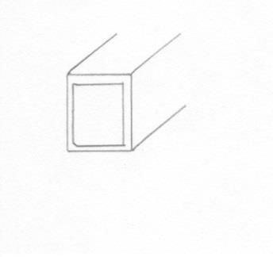 Tubing

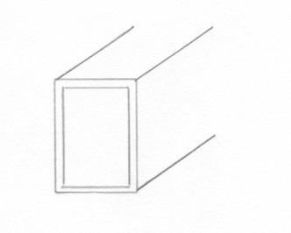

15. Tubing