Name_______________________________Date_____________________Class___________

**Basic Metal Shapes Handout 2**

**Directions**

Write the correct name beside each of the following basic metal shapes.

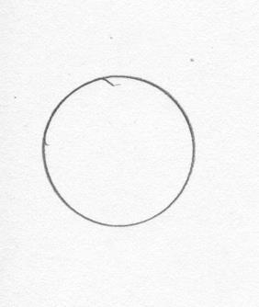

1. ____________________

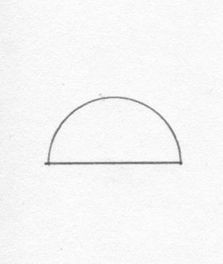

2. ____________________

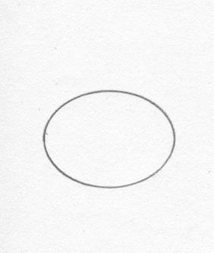

3. ____________________

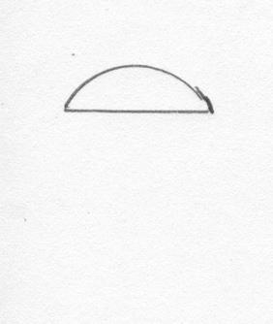

4. ____________________

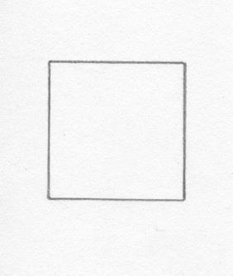

5. ____________________

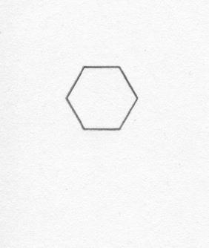

6. ____________________

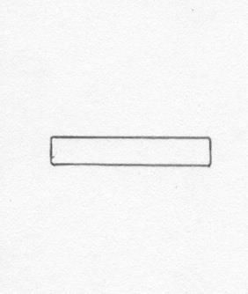

7. ____________________

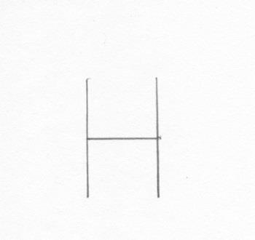

8. ____________________

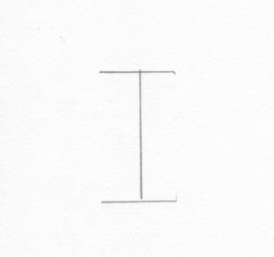

9. ____________________

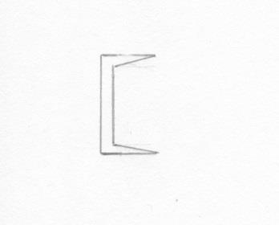



10. ____________________

11. 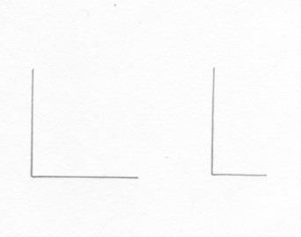 ____________________

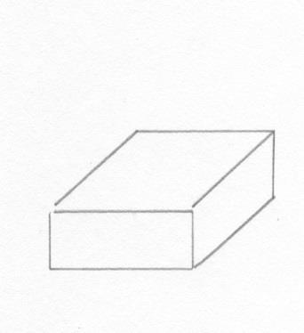

12. ____________________

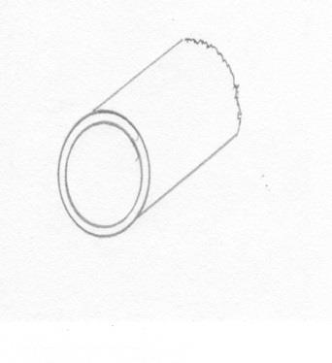

13. ____________________

14. 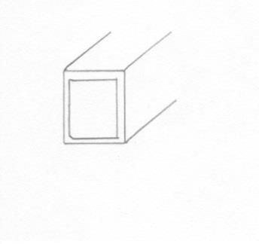 ____________________

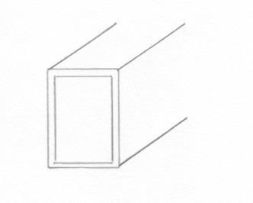

15. ____________________