Business Law and Ethics Presentation Rubric

Name: _______________________________

Oral Presentation – 100 possible points (total points below X 2)

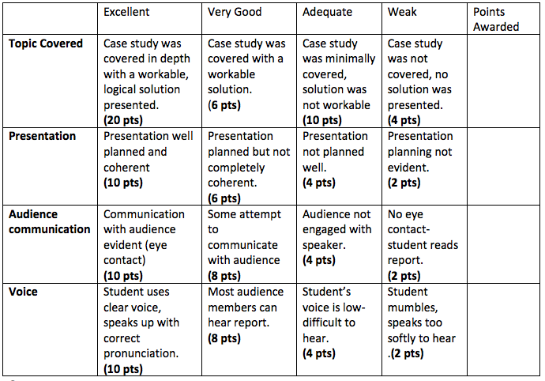

Comments:

