Layout Page 1
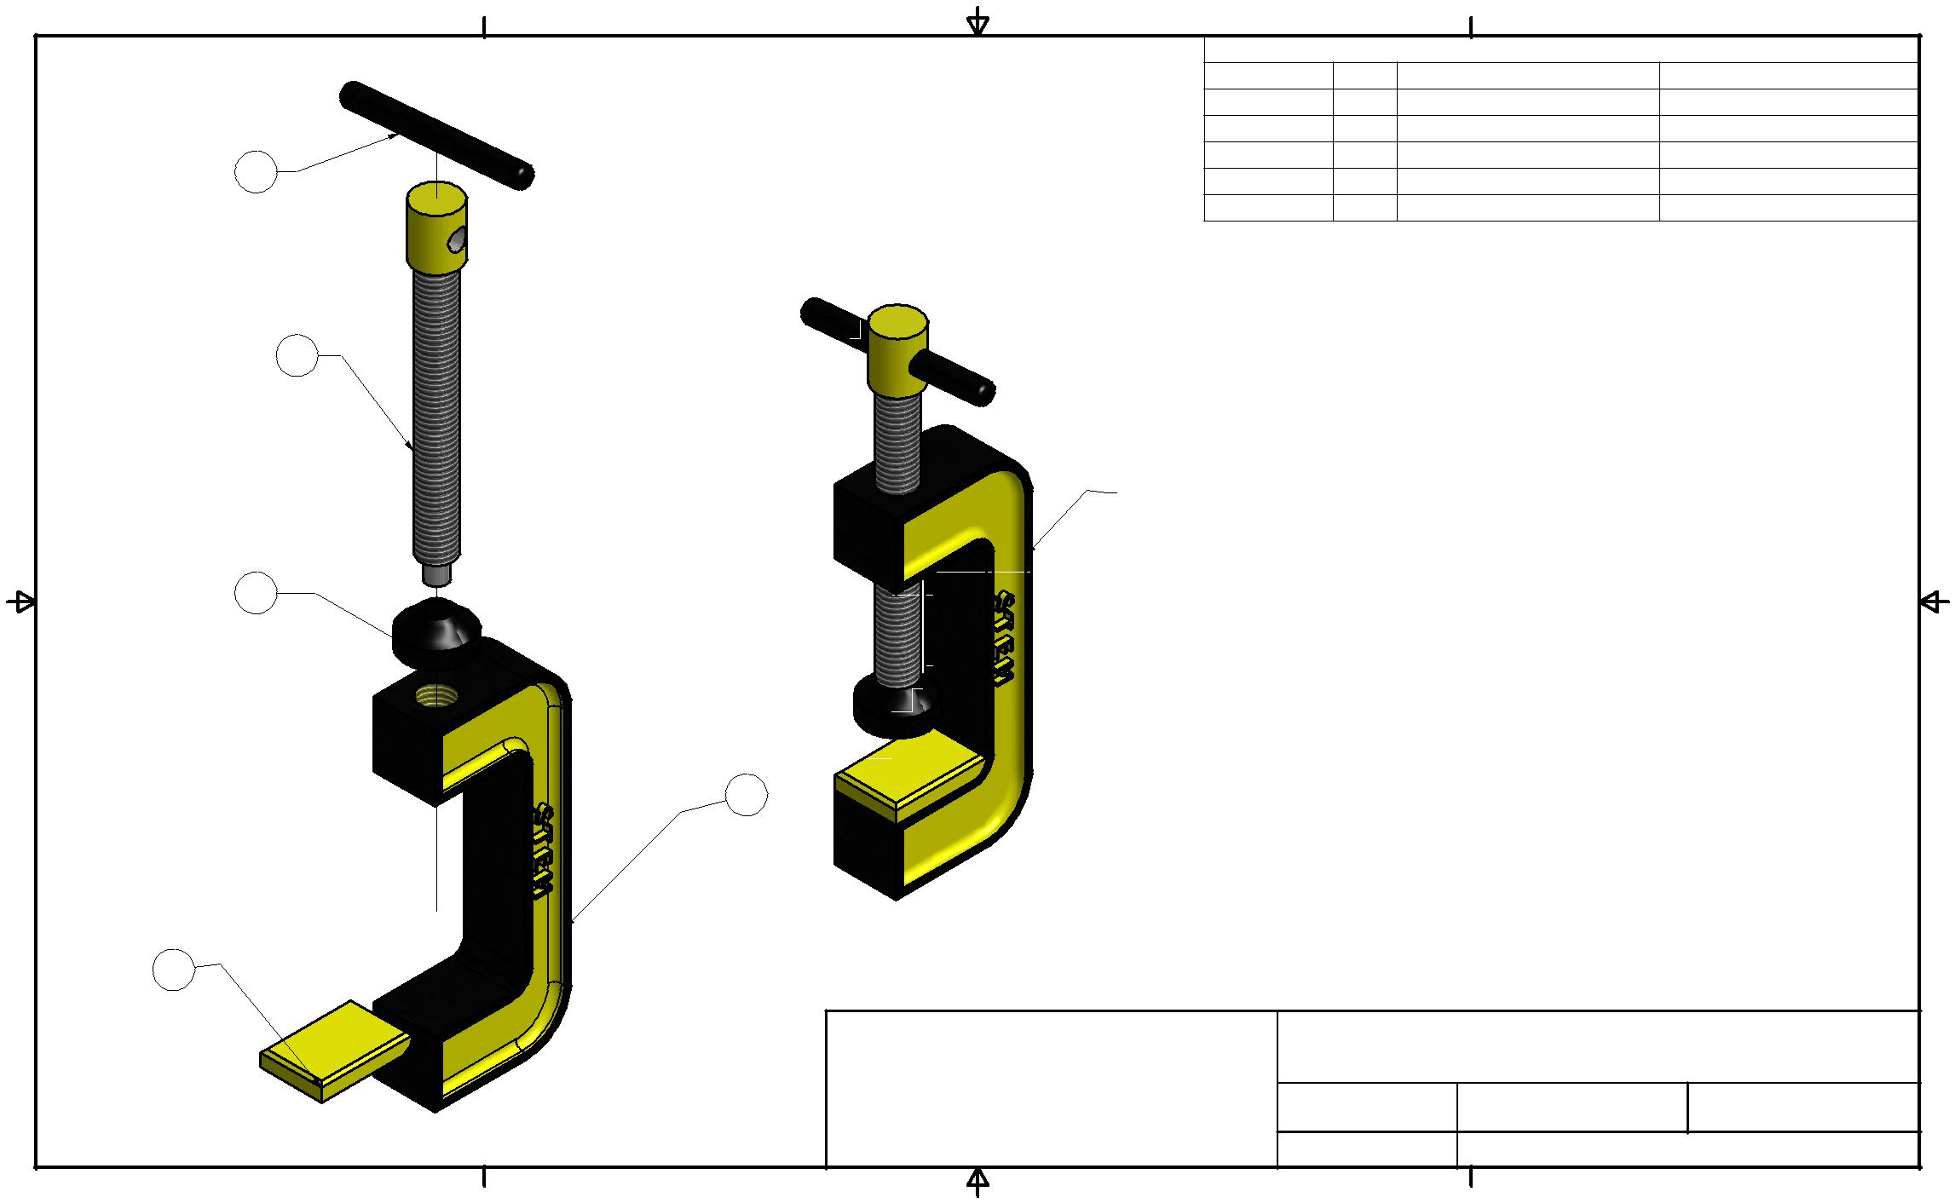
4 | 3 | 2 |  |  | 1
 |  |  |  | PARTS LIST
 |  | ITEM | QTY | PART NUMBER | MATERIAL
 |  | 1 | 1 | C-Clamp Base | Steel, Alloy
 |  | 2 | 1 | Protection Pad | Rubber, Silicone
 | 5 | 3 | 1 | Shaft Screw | Steel, Alloy
 |  | 4 | 1 | Screw Swivel | Steel
 |  | 5 | 1 | Tension Bar | Steel
B |  |  |  |  | B
 | 3

 | NOTE:
 | 1-YOU WILL CHANGE THE COLORS TO
4 | MATCH YOUR SCHOOL'S COLORS
 | 2-CHANGE STEM TO YOUR NAME OR INTIALS
 | 3-CHANGE 2014 TO YOUR GRADUATION YEAR

1

A | A
 | 2

 |  | OWNER: | TITLE: | C-CLAMP
 |  | UNIV. NORTH TEXAS | SIZE | DRAWN BY: | DATE:
 |  |  | DWG NO | SHEET 1 | OF 3
 |  |  | B | MRS. BAXTER | 1/3/2014
 |  |  | C-Clamp Assembled-Exploded Views
4 | 3 | 2 |  |  | 1

Layout Page 2
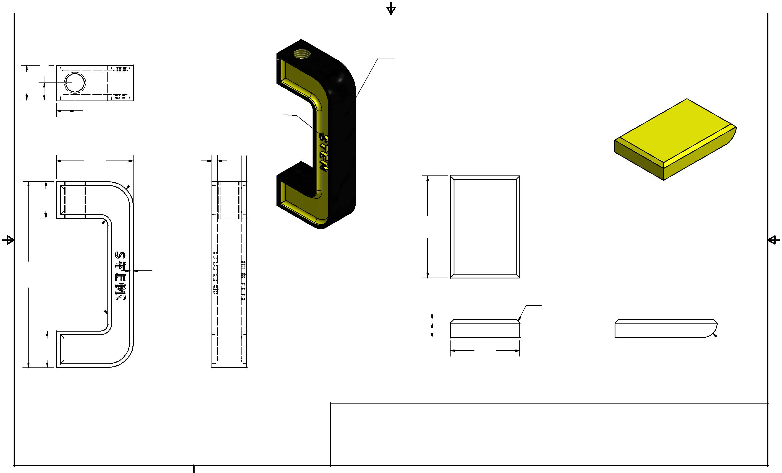
4 |  | 3 | 2 |  | 1

0019. | 509.
B | 10.00

 | REMEMBER YOU WILL:
 | 1-CHANGE COLORS TO MATCH YOUR SCHOOL'S
 | COLORS
 | 2-CHANGE STEM TO YOUR NAME OR INTIALS
 | 3-CHANGE 2014 TO YOUR GRADUATION YEAR
NOTE: THE LETTERS/NUMBERS | B
ARE A 2MM EXTRUSION

42.00 | 3.00

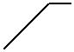R14.00 (2)

20.00

R4.00 (2)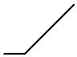

00102. | 2.00
 | ALL AROUND

NOTE:
2MM FILLET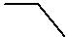

20.00

A

4

3.00

28.00

C-CLAMP BASE | 001.
SCALE 1:1

004. | 19.00

OWNER:

UNIV. NORTH TEXAS

3 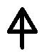 2

PROTECTION

PAD

SCALE 2:1

NOTE:
1MM CHAMFER

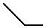R4.00

A

 | TITLE: | C-CLAMP
 | SIZE | DRAWN BY: |  |  | DATE:
 | B |  | MRS. BAXTER |  | 1/3/2014
 | DWG NO |  | SHEET 2 |  | OF 3
 | C-Clamp Assembled-Exploded Views
 |  |  |  |  | 1

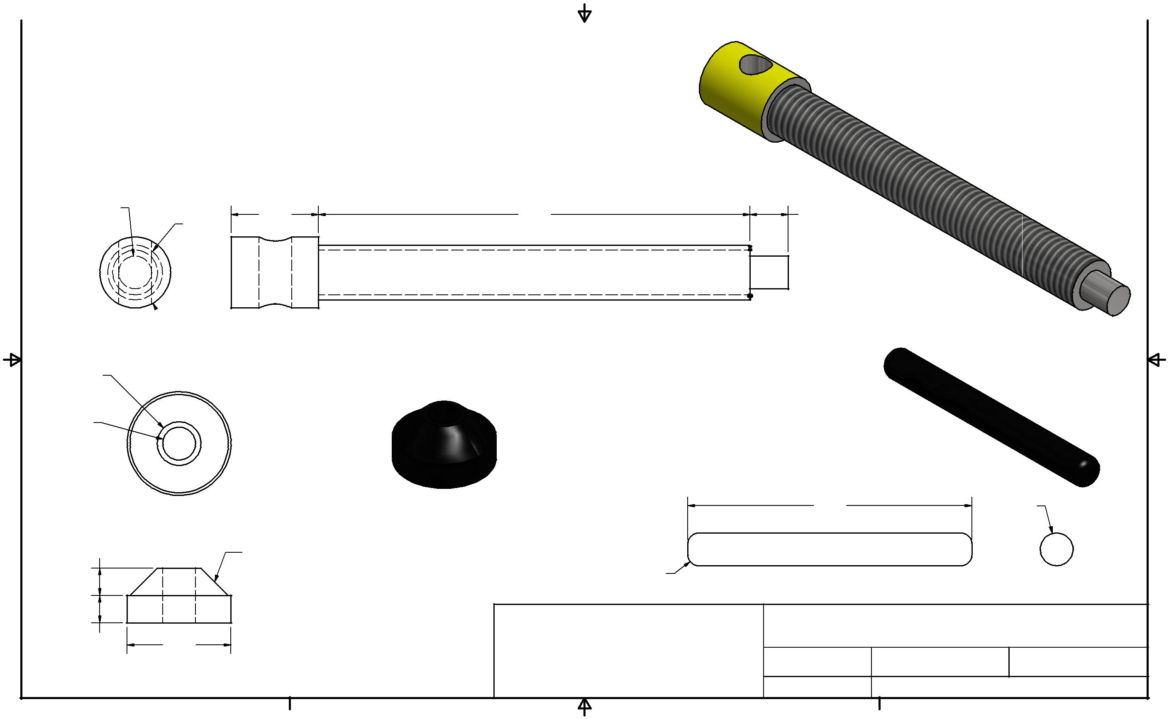
Layout Page 3

4 |  | 3 | 2 |  | 1

B

A

6.00

8.00

6.00

5.00

5.00

16.00
10.00

13.00

NOTE:

5MM CHAMFER

19.00

4

SHAFT SCREW

SCALE = 2:1

B

79.00 | 7.00

TENSION BAR

SCALE = 2:1

SCREW SWIVEL |  |  | 52.00 | 6.00
SCALE = 2:1 | R2.00 FILLET |  |  | A
 | BOTH ENDS
 | OWNER: | TITLE: | C-CLAMP
UNIV. NORTH TEXAS |  | SIZE | DRAWN BY: | DATE:
 |  | DWG NO | SHEET 3 OF 3
 |  | B | MRS. BAXTER | 1/3/2014
 |  | C-Clamp Assembled-Exploded Views
3 | 2 |  |  | 1

