Name: ____________________________________________________ Date: _______________________

CPR Demonstration Checklist
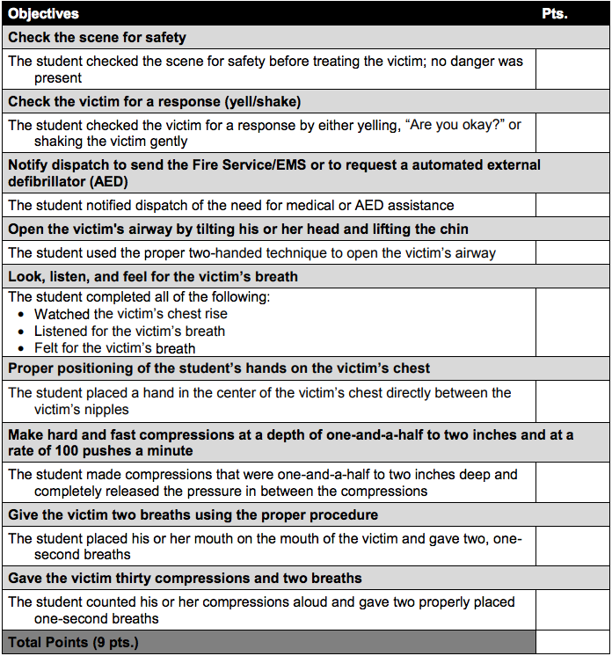
Comments:

