Color Theory Activity #1: Color Schemes

Student Name: ________________________ Date:

Instructions: Using a color wheel, select colors that represent the listed color scheme. Using map/color pencils, color in the objects to represent the chosen color scheme.

Scheme #1: Triad Scheme

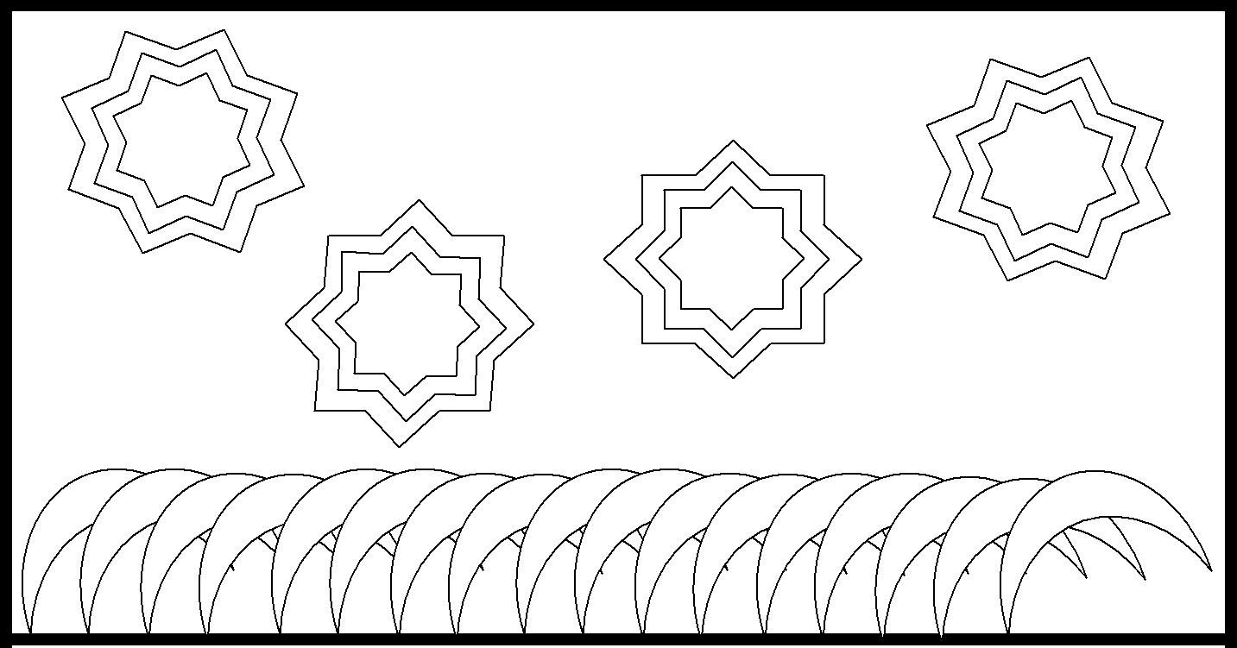

Scheme #2: Split-Complement Scheme
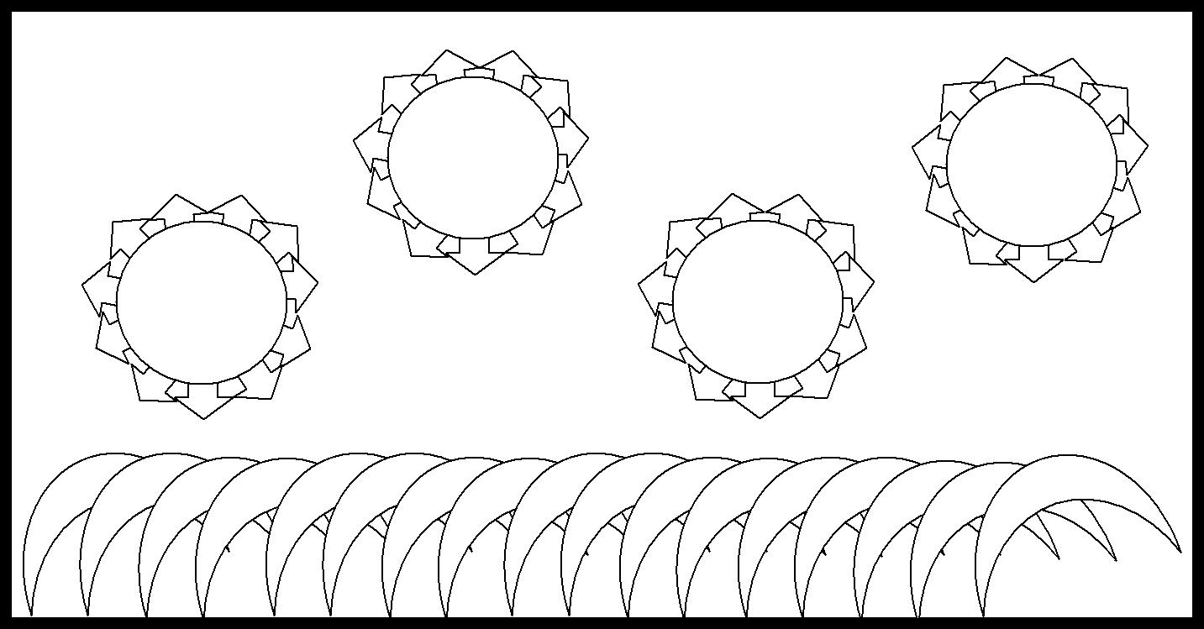

Scheme #3: Harmonious Pair Scheme

Scheme #4: Tetradic Scheme

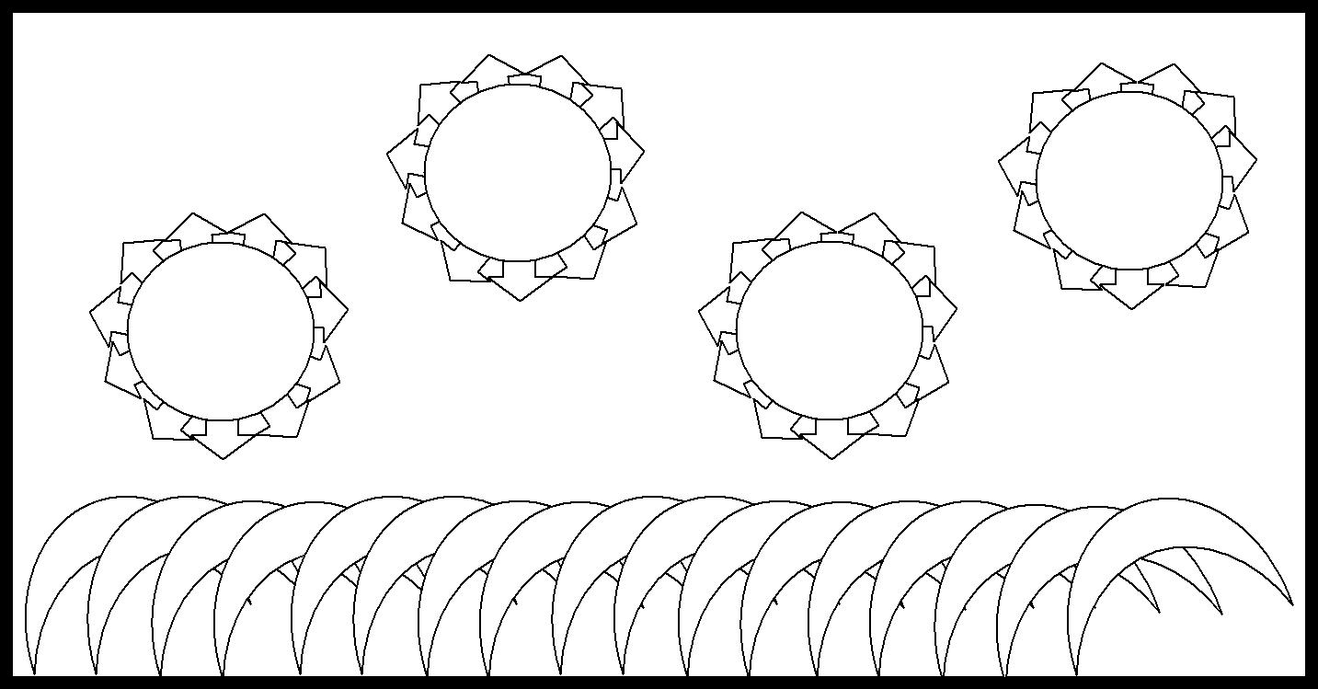

Scheme #5: Analogous Scheme
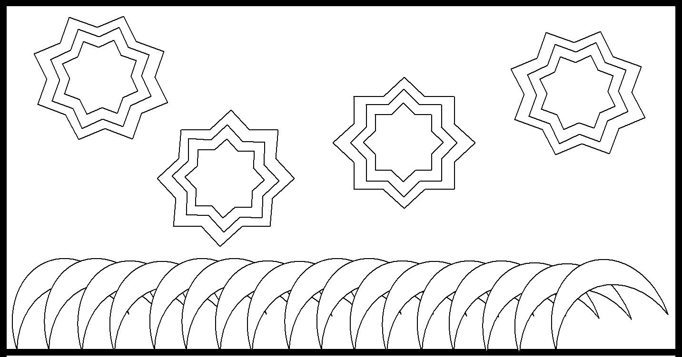

Record the #____ of your favorite scheme.

Record the Name/Type ___________________ of your favorite scheme.

Explain what it is about your favorite scheme that makes you like it more than the others.

