Color Theory Instructions for Activity #2 – Color Wheel
Student Name Date

- Using a computer software program of your choice, create a document size 8.5” x 11”.
- Save this document to your student folder as My Color Wheel.
- Add a text object with your first and last name.
- Draw a circle 5” x 5” and center it on the document.
- Draw an equilateral triangle (all sides of equal length) and center it inside the circle so that the tips of the triangle are resting on the edge of the circle.
- Choose a drawing object such as a circle, trapezoid, arc, or wedge.
- Draw the object and fill the shape with a RED color having an RGB value of 255, 0, 0.
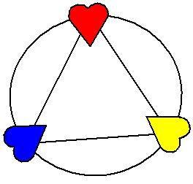
- Position this object at the intersection of the circle edge and triangle tip.
- Repeat the previous step, filling the shape with a BLUE color.
- Repeat again, filling the shape with a YELLOW color.
See image at right for a reference.
- Continue in this same manner to draw the same object or copy and paste the same object around the edge of the circle.
- You will need 9 objects positioned between each of the primary colored objects.
It’s ok if the objects slightly overlap each other.
- Change the fill color of the objects using RGB values to determine the color.
- Set the color to gradually change from one primary color to the next.
- Be sure to properly represent the 3 secondary colors of Orange, Green, and Violet.
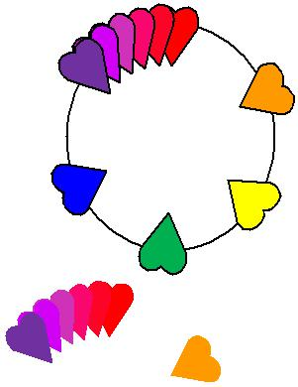
- When you are finished, select all the objects and remove the outline color.
- Save your changes and close the document.
