Color Theory Instructions for Activity #3 – Paint Chips

Student Name Date

Activity #3: Using RGB Values and CMYK values to recreate pigment color

- Use the paint chip sample your instructor provides you.

- Using a computer software program of your choice, create a document size 8.5” x 11”.

- Set the color mode to CMYK.

- Save this document to your student folder as My Paint Chip Sample.

- Add a text object with your first and last name.
- Draw shapes/objects that are similar to the shapes of the paint samples.

- Fill the objects with color that are as close as possible to the paint chip sample.

- Create text objects to label the drawing objects with their CMYK values.

- Change the color mode to RGB.

- Create text objects to label the drawing objects with their RGB values.

11. Save your changes. |  | Cyan: 22 | Red: 0
 |  | Magenta: 14 | Green: 14
12. Print your document. |  | Yellow: 21 | Blue: 112
 | Ice | Black: 0
13. Staple the paint sample to the printout.
14. Close the document.
 |  | Cyan: 52 | Red: 0
Example: |  | Magenta: 7 | Green: 34
 | Pale | Yellow: 24 | Blue: 107
 |  | Black: 0
 | Blue
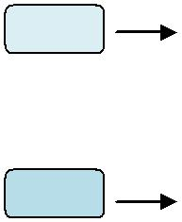

Aquarium

