Costing Garments Student Notes Key

Single Garment Costing
- Costing is the economic value placed on resources to make a fashion product.

- Fashion designers must know how to accurately cost an item. Accurate costing will ensure the designer is paid for all materials used to make the garment, shipping, and a profit percentage.

- First: Calculate fabric: Multiply the cost of fabric per yard by the number of yards used to
make the garment. Example: $7.99 per yard x 3 yards used = 23.97

- Second: Calculate lining and interfacing (only if needed): Multiply the cost of lining/interfacing per yard by the number of yards used to make the garment

Example: $2.99/yard x 3 yards used = $8.97

- Third: Calculate notions: Add cost of notions to previous total.
Example: 32.94 (fabric and lining) + .75 (1 zipper) + .15 (1 button) = $33.84

- Fourth: Calculate the labor cost for cutting: Multiply the hours it took to cut the fabric (and possibly lining) by the amount you are willing to pay someone to cut.
Example: 1 hour to cut x $8.00 an hour wage = $8.00 $33.84 + 8.00 = $41.84

- Fifth: Calculate labor cost for sewing: Multiply the hours it took to sew the fabric (and
possibly lining) by the amount you are willing to pay someone to sew.

Example: 4 hours to sew x $12.00 an hour wage = $48.00 41.84 (cutting labor) + 48.00 (sewing labor) = $89.84

- Sixth: Calculate overhead costs: Add 12% of the subtotal to your cost. Overhead covers resources needed to operate, such as facility rent or utility costs.
Example: 89.84 x .12 = $10.78 (overhead) Add 10.78 to 89.84 = $100.62 new subtotal

- Seventh: Calculate your marginal cost of production: Add 20% of the subtotal to your cost. This cost is added for the extra time it takes to make just one piece instead of multiples at once. Example: 100.62 x .20 = $20.12 (margin) Add 20.12 to 100.62 = $120.74 This is the total cost to make your single garment

- Eighth: Calculate your profit: Now you get to get paid! Multiply total cost by 2.2. This is the industry standard calculation to determine how much the designer should be paid. Example: 120.74 x 2.2 = $265.63 Final sells price of garment

The garment cost $120.74; you make $144.89 on your garment

Apparel Production in Bulk Costing

- Designers use apparel production cost sheets to analyze their expenses in making garments and to analyze profit margins. In a professional cost sheet you will need to know how many garments you will order, the season they are to be sold in retail, seam allowance to be used in construction, a diagram of the garment, sizes and colors you would like it made in, quantity and price of fabrics and trimmings needed.

12.
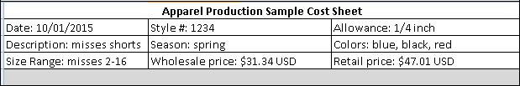

- Date field: Enter the date you plan to place your order

- Style #: Enter a style number that you assign to your garment. This will help keep your orders organized when ordering more than one garment

- Allowance: Enter the seam allowance you want used when your garment is being constructed

- Description: Enter a short description of your garment for the manufacturer’s reference

- Season: Enter what season this garment will be marketed and sold to

- Colors: Enter what colors you want the garment to be made in

- Size ranges: Enter what sizes you want the garment to be made in

- Wholesale price: Enter what the garment will be sold for at wholesale

- Retail price: Enter what the garment will be sold for at retail

13.
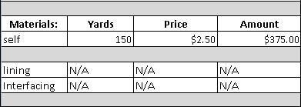

- Self is the outside shell of the garment

- Yards, price, and amount fields for self: Multiply yards needed to make all shorts by price per yard. This will give you the total cost of yourself fabric needed. Example: 150 x 2.5 = 375.00

- Yards, price, amount fields for lining and interfacing: You would need to do the same calculation for the lining and interfacing needed. In this example our shorts do not need interfacing or lining.
14.
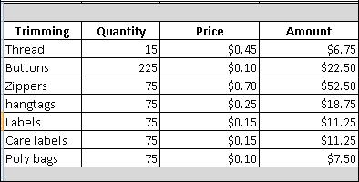

- For each trimming item, multiply its quantity amount by its price amount for its cost

- Before you order from the manufacturer, you will need to confirm the amounts of each trimming they need to make your full order of garments.

15.
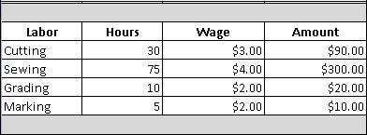

- For each labor cost, multiply the hours it took to perform the labor by the wage amount paid to that worker to get the total amount that employee was paid for his or her labor.

- Before you order your garment, you can get an approximate cost for each labor item. Know that it is possible for the pre-order amount to change post-production.

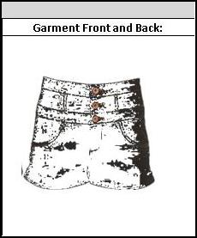
- For each garment you are seeking to get manufactured, include a garment sketch of what you are wanting it to look like. Include the garments

front and back in your sketch. In an actual cost sheet, you will use graphic design software. This example has a mock sketch using clip art.

- Calculating total cost: After you have filled out all portions of your cost sheet, you are ready to get your total cost. For our example, you would add:

375 + 6.75 + 22.50 + 52.50 + 18.75 + 11.25 + 11.25 + 7.50 + 90 + 300 + 20 + 10 = $925.50 total cost

- Add overhead cost: Overhead cost is typically 12%. Calculate what 12% of your total cost is and add it to your total cost.
Example: 925.50 * .12 = $111.06 overhead cost

925.50 + 111.06 = $1036.56 total with overhead

- Add FOB cost: FOB cost is the amount you would have to pay to get the garments shipped to you, either by flight or sea. Sea freight is calculated based on your garments’ volume. Airfreight is based on your garments’ weight. You should research to decide what freight works best for your garments based on your timeline and price before you start production of garments. Ask your manufacturer for an approximation of volume and weight to get an estimate for your FOB cost.

- Calculating mark-up: Once you have your total cost, overhead and FOB, you will need to determine your mark-up. Mark-up is the increase you add after all the expenses to profit from your garments. Add your total cost, overhead and FOB.

925.50 + 111.06 + 32 = 1068.56

Multiply this total by 2.2 to get your mark-up 1068.56 x 2.2 = $2350.83

Your cost with mark-up is what you would sell your garments for at wholesale.

- Calculating wholesale cost: Wholesale is what you, the designer, would sell your shorts for

to the retailer that will then sell them to the customer. Example: $2350.83 / 75 (number of shorts made) = $31.34 price per unit (shorts)

- The retailer will then mark up the cost of the shorts so that the store can also profit from each sale.

For example, if the store paid $31.34 per shorts, they may mark up the price 50%. This would make the shorts $47.01 to the customer.

31.34 x .5 = 15.67

15.67 + 31.34 = $47.01

