Costing Garments Student Notes

Single Garment Costing

- ________________ is the economic value placed on ________________ to make a fashion
________________.

- Fashion ________________ must know how to accurately cost an item. Accurate costing will ensure the designer is ________________ for all materials used to make the garment,
________________, and a ________________ percentage.

- First: Calculate ________________: Multiplying the cost of fabric per ________________ by the number of yards ________________ to make the garment.

Example: $7.99 per yard x 3 yards used = 23.97

- Second: Calculate ________________ and ________________ (only if needed): Multiply the cost of lining/interfacing per ________________ by the number of yards ________________
to make the garment
Example: $2.99/yard x 3 yards used = $8.97

- Third: Calculate ________________: Add cost of notions to previous ________________
Example: 32.94 (fabric and lining) + .75 (1 zipper) + .15 (1 button) = $33.84

- Fourth: Calculate the ________________ ________________ for ________________: Multiply the ________________ it took to cut the fabric (and possibly lining) by the amount you are willing to pay someone to cut

Example: 1 hour to cut x $8.00 an hour wage = $8.00 $33.84 + 8.00 = $41.84

- Fifth: Calculate ________________ ________________ for ________________: Multiply the

________________ it took to sew the fabric (and possibly lining) by the amount you are willing to pay someone to sew

Example: 4 hours to sew x $12.00 an hour wage = $48.00 41.84 (cutting labor) + 48.00 (sewing labor) = $89.84

- Sixth: Calculate ________________ costs: Add ______ of the subtotal to your cost. Overhead covers resources needed to _______________, such as facility rent or utility costs.

Example: 89.84 x .12 = $10.78 (overhead) Add 10.78 to 89.84 = $100.62 new subtotal

- Seventh: Calculate your ________________ cost of ________________: Add ______ of the subtotal to your cost. This cost is added for the extra ______________ it takes to make just one piece instead of multiples at once.

Example: 100.62 x .20 = $20.12 (margin) Add 20.12 to 100.62 = $120.74 This is the total
cost to make your single garment

- Eighth: Calculate your ________________: Now you get to get paid! Multiply total cost by

_______ This is the industry-________________ calculation to determine how much the designer should be paid.

Example: 120.74 x 2.2 = $265.63 Final sells price of garment the garment cost $120.74, you make $144.89 on your garment

Apparel Production in Bulk Costing

- Designers use apparel production cost sheets to analyze their expenses in making garments and to analyze profit margins. In a professional cost sheet, you will need to know how many
________________ you will order, the ________________ they are to be sold in retail, seam

________________ to be used in construction, a ________________ of the garment, sizes, and colors you would like it made in, ________________ and price of fabrics and trimmings needed.

12.
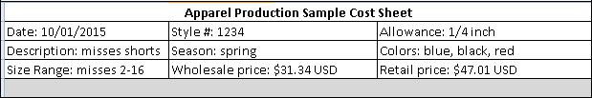

- Date field: Enter the __________ you plan to ______________ your order

- Style #: Enter a style number that you ____________ to your garment. This will help keep your orders ____________ when ordering more than one garment

- Allowance: Enter the ____________ allowance you want used when your garment is being constructed

- Description: Enter a short description of your garment for the manufacturer’s ____________

- Season: Enter what season this garment will be ____________ and sold to

- Colors: Enter what colors you want the ____________ to be made in

- Size ranges: Enter what __________ you want the garment to be made in

- Wholesale price: Enter what the garment will be _______ for at wholesale

- Retail price: Enter what the garment will be sold for at ___________

13.

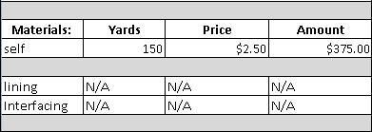

Example: 150 x 2.5 = 375.00

- ____________ is the outside ____________ of the garment.

- Yards, price, and amount fields for self: Multiply yards needed to make all shorts by ____________ per ____________. This will give you the total

- Yards, price, amount fields for lining and interfacing: You would need to do the same calculation for the lining and interfacing needed. In this example, our shorts do not need interfacing or lining.
14.

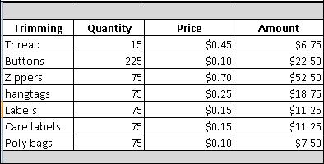

- For each trimming item, multiply it’s ____________ amount by its
__________ amount for its cost.

- Before you order from the manufacturer, you will need to confirm the amounts of each ____________ they need to make your full

____________ of garments.

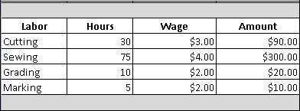
15.

- For each labor cost, multiply the __________ it took to perform the

__________ by the __________ amount paid to that worker to get the total amount that employee was paid for his or her labor.

- Before you order your garment, you can get an ____________ cost for each labor item. Know that it is possible for the ____________ amount to change ____________.
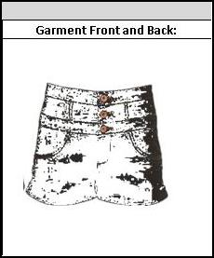
- For each garment, you are seeking to get manufactured, include a garment
____________ of what you are wanting it to look like. Include the garments ____________ and ____________ in your sketch. In an actual cost sheet, you will use graphic design software. This example has a mock sketch using clip art.

- Calculating total cost: After you have filled out all portions of your cost sheet, you are ready to get your ____________ ___________. For our example, you would add:

375 + 6.75 + 22.50 + 52.50 + 18.75 + 11.25 + 11.25 + 7.50 + 90 + 300 + 20 + 10 = $925.50 total cost

- Add overhead cost: Overhead cost is typically __________. Calculate what _________ of your total cost is and add it to your total cost.
Example: 925.50 * .12 = $111.06 overhead cost
925.50 + 111.06 = $1036.56 total with overhead

- Add FOB cost: FOB cost is the amount you would have to pay to get the garments

____________ to you, either by ____________ or _______. Sea freight is calculated based on your garments’ ____________. Airfreight is based on your garments’ ____________. You should ____________ to decide what freight works best for your garments based on your timeline and price before you start ____________ of garments. Ask your manufacturer for an approximation of volume and weight to get an estimate for your ______ cost.

- Calculating mark-up: Once you have your total cost, overhead and FOB, you will need to determine your ____________. Mark-up is the ____________ you add after all the expenses to ____________ from your garments. Add your total cost, overhead and FOB

925.50 + 111.06 + 32 = 1068.56

Multiply this total by 2.2 to get your mark-up 1068.56 x 2.2 = $2350.83

Your cost with mark-up is what you would _________ your garments for at ____________.

- Calculating wholesale cost: Wholesale is what you, the designer, would ________ your shorts for to the ____________ that will then _________ them to the ____________.

Example: $2350.83 / 75 (number of shorts made) = $31.34 price per unit (shorts)

- The ____________ will then ____________ the cost of the shorts so that the ____________

can also ____________ from each sale.

For example, if the store paid $31.34 per shorts, they may mark up the price 50%. This would make the shorts $47.01 to the customer.

31.34 x .5 = 15.67

15.67 + 31.34 = $47.01

