Requirements for Contracts Flash Card
Business Law ‐ Creation of Offers

Independent Practice Assignment #1 Rubric
Student Name: ________________________________________
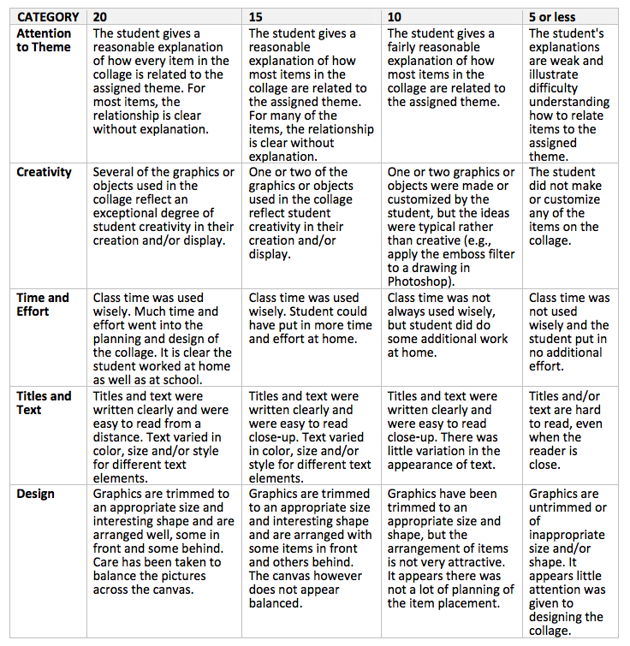
Total Score___________

Maximum 100 Points

