Write a Case
Business Law ‐ Creation of Offers

Independent Practice Assignment #2 Rubric

Student Name: ________________________________________
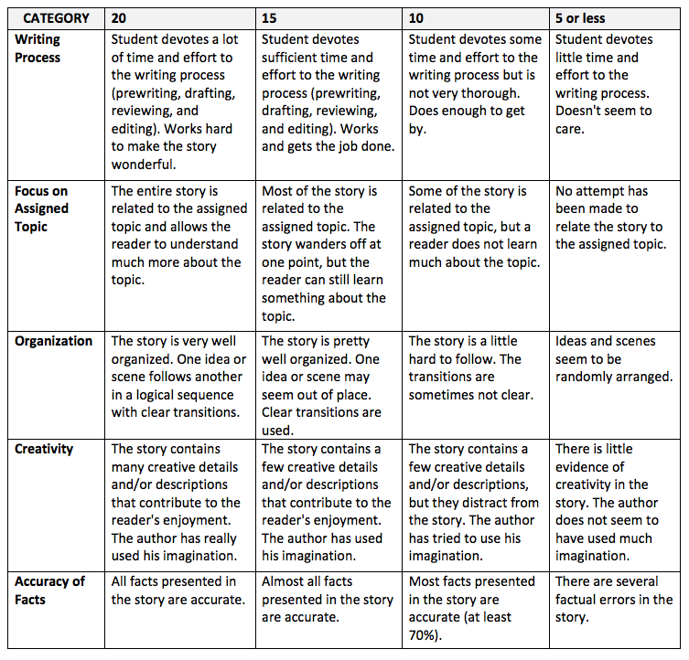
Total Score __________
Maximum 100 Points

