Name___________________________________ Date____________________

Criminal Justice System and the Courts Crossword Puzzle

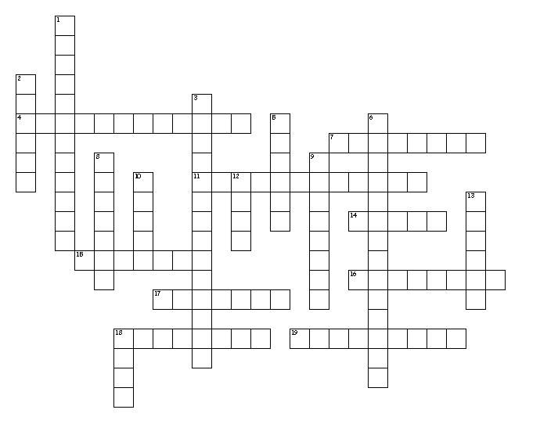

Across

- The highest court in the federal system
- There are 254 of these in Texas
- Document that created the judicial branch
- Type of case that deals with an individual’s private rights
- Court system that deals with United States laws
- Type of case when someone is accused of committing a crime
- There are 18 Statutory _______Courts in Texas
- Court that hears felony cases in Texas
- Means by which federal judges are placed in office

Down

- The Court of Criminal Appeals hears these appeals in the state of Texas
- There are two courts of last _______ in Texas
- Hears cases of city ordinance violations
- The Texas Supreme Court is located here
- The Supreme Court's authority to decide what is constitutional, as decided in Marbury v. Madison
- Means by which judges in Texas are placed in office
- Justice of the Peace does not have to be a licensed one of these
- Court system that deals with state laws
- Number of Supreme Court justices
- What an appellate court hears from a lower court
- Two court systems in the United States

Criminal Justice System and the Courts Crossword Puzzle Word Bank

Appeal
Appointed
Attorney
Austin
Civil
Constitution
Counties
Criminal
Death Penalty
District
Dual
Elected
Federal
Judicial Review
Municipal Court
Nine
Probate
Resort
State
Supreme Court

