Cultural Differences Presentation Rubric
Country:
Name: ____________________________________ Teacher: ____________________________
Date of Presentation: ________ Title of Work_________________________________________

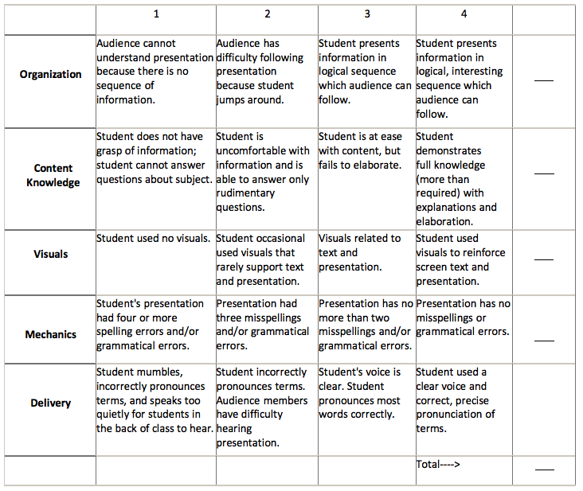

Teacher’s Comments:

