Name: ____________________________________________________ Score: _____/100

DR. GABIC Math TAKS Based Scenario Problems

1. Based on the scores given below what is the class grade average for Period #1?

Period #1
Student #1= | 97 | Student #13= | 81
Student #2= | 90 | Student #14= | 95
Student #3= | 91 | Student #15= | 95
Student #4= | 75 | Student #16= | 93
Student #5= | 82 | Student #17= | 100
Student #6= | 93 | Student #18= | 74
Student #7= | 81 | Student #19= | 82
Student #8= | 100 | Student #20= | 91
Student #9= | 96 | Student #21= | 82
Student #10= | 86 | Student #22= | 100
Student #11= | 66 | Student #23= | 88
Student #12= | 70 | Student #24= | 83

Bubble in what you have figured out the class average is for Period 1.
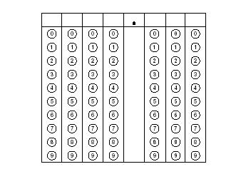

2. Based on the scores given below what is the class grade average for Period #2?

Period #2
Student #1= | 100 | Student #13= | 74
Student #2= | 100 | Student #14= | 62
Student #3= | 96 | Student #15= | 90
Student #4= | 87 | Student #16= | 95
Student #5= | 76 | Student #17= | 100
Student #6= | 71 | Student #18= | 88
Student #7= | 88 | Student #19= | 85
Student #8= | 75 | Student #20= | 72
Student #9= | 95 | Student #21= | 84
Student #10= | 82 | Student #22= | 89
Student #11= | 93
Student #12= | 91

Bubble in what you have figured out the class average is for Period 2.

3. Based on the scores given below what is the class grade average for Period #4?

Period #4
Student #1= | 95 | Student #13= | 100
Student #2= | 90 | Student #14= | 95
Student #3= | 88 | Student #15= | 95
Student #4= | 85 | Student #16= | 98
Student #5= | 84 | Student #17= | 74
Student #6= | 74 | Student #18= | 68
Student #7= | 82 | Student #19= | 70
Student #8= | 81 | Student #20= | 100
Student #9= | 78 | Student #21= | 100
Student #10= | 76
Student #11= | 79
Student #12= | 83

Bubble in what you have figured out the class average is for Period 4.

4. Based on the scores given below what is the class grade average for Period #7?

Period #7
Student #1= | 100 | Student #13= | 100
Student #2= | 95 | Student #14= | 100
Student #3= | 95 | Student #15= | 98
Student #4= | 95 | Student #16= | 88
Student #5= | 88 | Student #17= | 74
Student #6= | 83 | Student #18= | 72
Student #7= | 78 | Student #19= | 66
Student #8= | 68 | Student #20= | 78
Student #9= | 69 | Student #21= | 80
Student #10= | 71 | Student #22= | 81
Student #11= | 87 | Student #23= | 100
Student #12= | 95

Bubble in what you have figured out the class average is for Period 7.

- What percentage of the students in ALL classes made an “A” (100-90)? There are a total of 90 students and 38 made an “A”.
HINT: 100/90 = 1.11

- What percentage of the students in ALL classes made a “B” (89-80)? There are a total of 90 students and 27 made a “B”

HINT: 100/90 = 1.11

- What percentage of the students in ALL classes made a “C” (79-75)? There are a total of 90 students and 8 made a “C”
HINT: 100/90 = 1.11

- What percentage of the students in ALL classes made a “D” (74-70)? There are a total of 90 students and 11 made a “D”

HINT: 100/90 = 1.11

- What percentage of the students in ALL classes made an “F” (69-0)? There are a total of 90 students and 6 made an “F”
HINT: 100/90 = 1.11

- Look at the pie chart below. Which class scored the highest overall on the Light Bot Game?
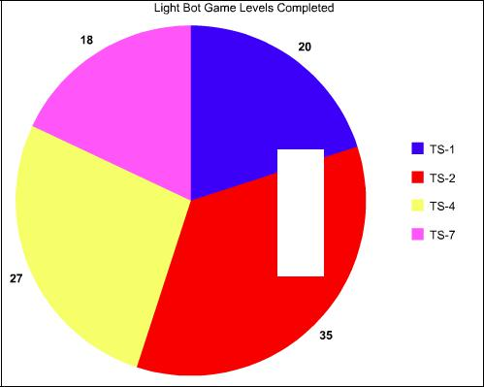

P

1

P
2

P

Using the graphs provided below, answer the following questions.

P1 P2
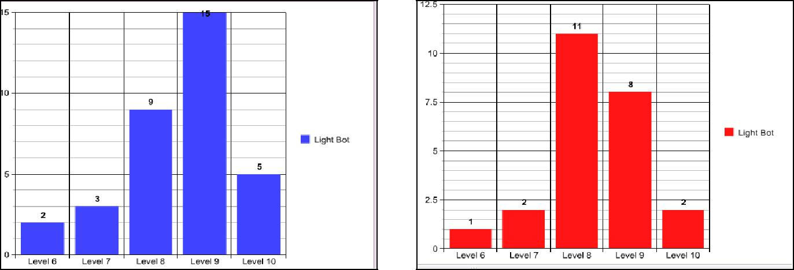

P4 P7
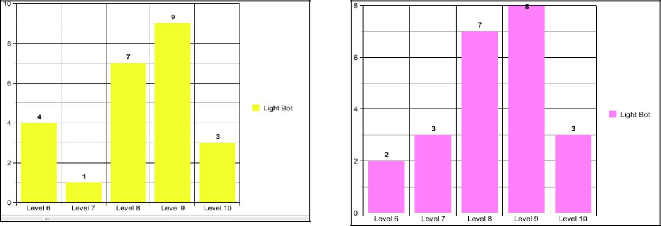

- Which class had the most Level 10 completed?

- Which class had the least Level 10 completed?

- Which two classes tied on their score for Level 7?

- Which two classes tied on their score for Level 8?

- Which class scored the highest on Level 9?

