Name_______________________ Date _________________
Class__________

DR. GABIC and Problem Solving Test

True/False

Indicate whether the sentence or statement is true or false.

____ | 1. |  | DR. GABIC’s method of problem solving is completely different than
 |  | the Scientific method of problem solving.
____ | 2. |  | A good positive ATTITUDE is everything!
____ | 3. |  | When we make good decisions or choices we will get advice from
 |  | someone that is NOT respected by the positive leaders.
____ | 4. |  | A good employee does not Lie or Steal, nor do they tolerate those
 |  | that do.
____ | 5. |  | According to Osborn’s Rules for brainstorming, the wilder, offbeat,
 |  | and impractical ideas the better.
____ | 6. |  | In Osborn’s Rules for brainstorming, criticism is ruled out.
____ | 7. |  | When a teacher is correcting another student in class, it is
 |  | inappropriate to laugh at them.
____ |  | 8. | We should get advice from someone who has lots of pride.
____ | 9. |  | Honesty and integrity are important for you to be able to live a
 |  | productive and successful life.
____ | 10. |  | When answering a writing prompt, your first sentence should make
 |  | sure your TOPIC sentence matches the prompt.

Multiple Choice

Identify the letter of the choice that best completes the statement or answers the question.

____ 11. A good employee will make it to work every day:
- none of these
- on Time (or early)
- just in Time
- when they have Time

____12. When brainstorming, _____________ is wanted.
- all of these
- quantity
- none
- a little

____13. When solving personal problems we should get advice from:
- neighborhood bum
- someone trustworthy
- anyone we know
- does not matter

____14. When brainstorming our ideas should be:
- the younger the better
- the older the better
- the wilder the better
- the slower the better

Matching (Continued on Next Page)

Match the explanations to the problem solving steps (numbers 15- 19) to the letters in the diagram on the next page. There are six steps to the problem solving sequence. Step #1 is “ Define the problem” and it has been given to you. List the next five steps by placing the letter of the step in the blank next to the numbers 15-19. Remember, “DR. GABIC” is the acronym that we use to help us with problem solving.

____15. Set the desired Results and Goals

____16. Come up with Alternative solutions (at least 3)
____17. Implement the solution
____18. Compare the results with the problem and Change if necessary.
____19. Choose the Best solution

Match the steps of the Universal System Model.

Step #1 is to Define the problem clearly:

- Step #2 is...

- Step #3 is....

- Step #4 is....

- Step #5 is....

- Step #6 is....

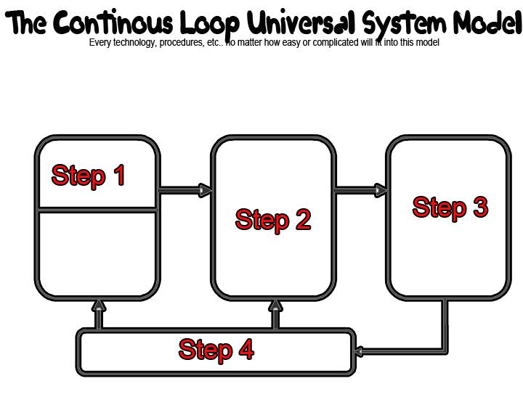

- Input
- Output
- Process
- Feedback

____ | 20. | Step 1
____ | 21. | Step 2
____ | 22. | Step 3
____ | 23. | Step 4

Match the steps for the Scientific Problem Solving method
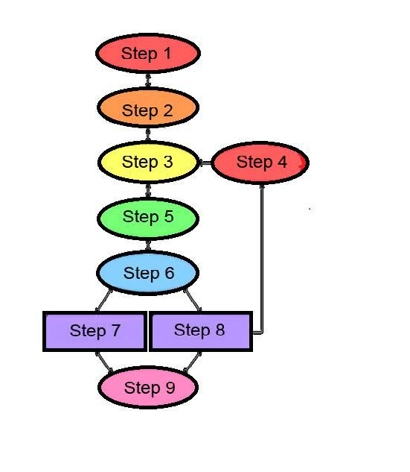

- Ask a question
- Do background research
- Construct hypothesis
- Think or try again
- Test with an experiment
- Analyze results or Draw conclusion
- Hypothesis is TRUE
- Hypothesis is False or partially true
- Report results

____ | 24. | Step 1
____ | 25. | Step 2
____ | 26. | Step 3
____ | 27. | Step 4
____ | 28. | Step 5
____ | 29. | Step 6
____ | 30. | Step 7
____ | 31. | Step 8
____ | 32. | Step 9

There are six (6) steps to the Scientific Problem Solving Process.
Put them into the correct order
- STATE the problem
- FORM a hypothesis
- TEST the hypothesis
- COLLECT the data
- ANALYZE the data
- Draw CONCLUSION

____ | 33. | Step 1 is............
____ | 34. | Step 2 is............
____ | 35. | Step 3 is............
____ | 36. | Step 4 is............
____ | 37. | Step 5 is............
____ | 38. | Step 6 is............

