Name:____________________________________ Date:_____________________________________

Debate Rubric
 | Objectives |  | 4 pts. | 3 pts. | 2 pts. Needs Some |  | 1 pt. Needs Much |  |  | N/A |  |  | Pts.
 |  |  | Excellent | Good | Improvement |  | Improvement
 | Information
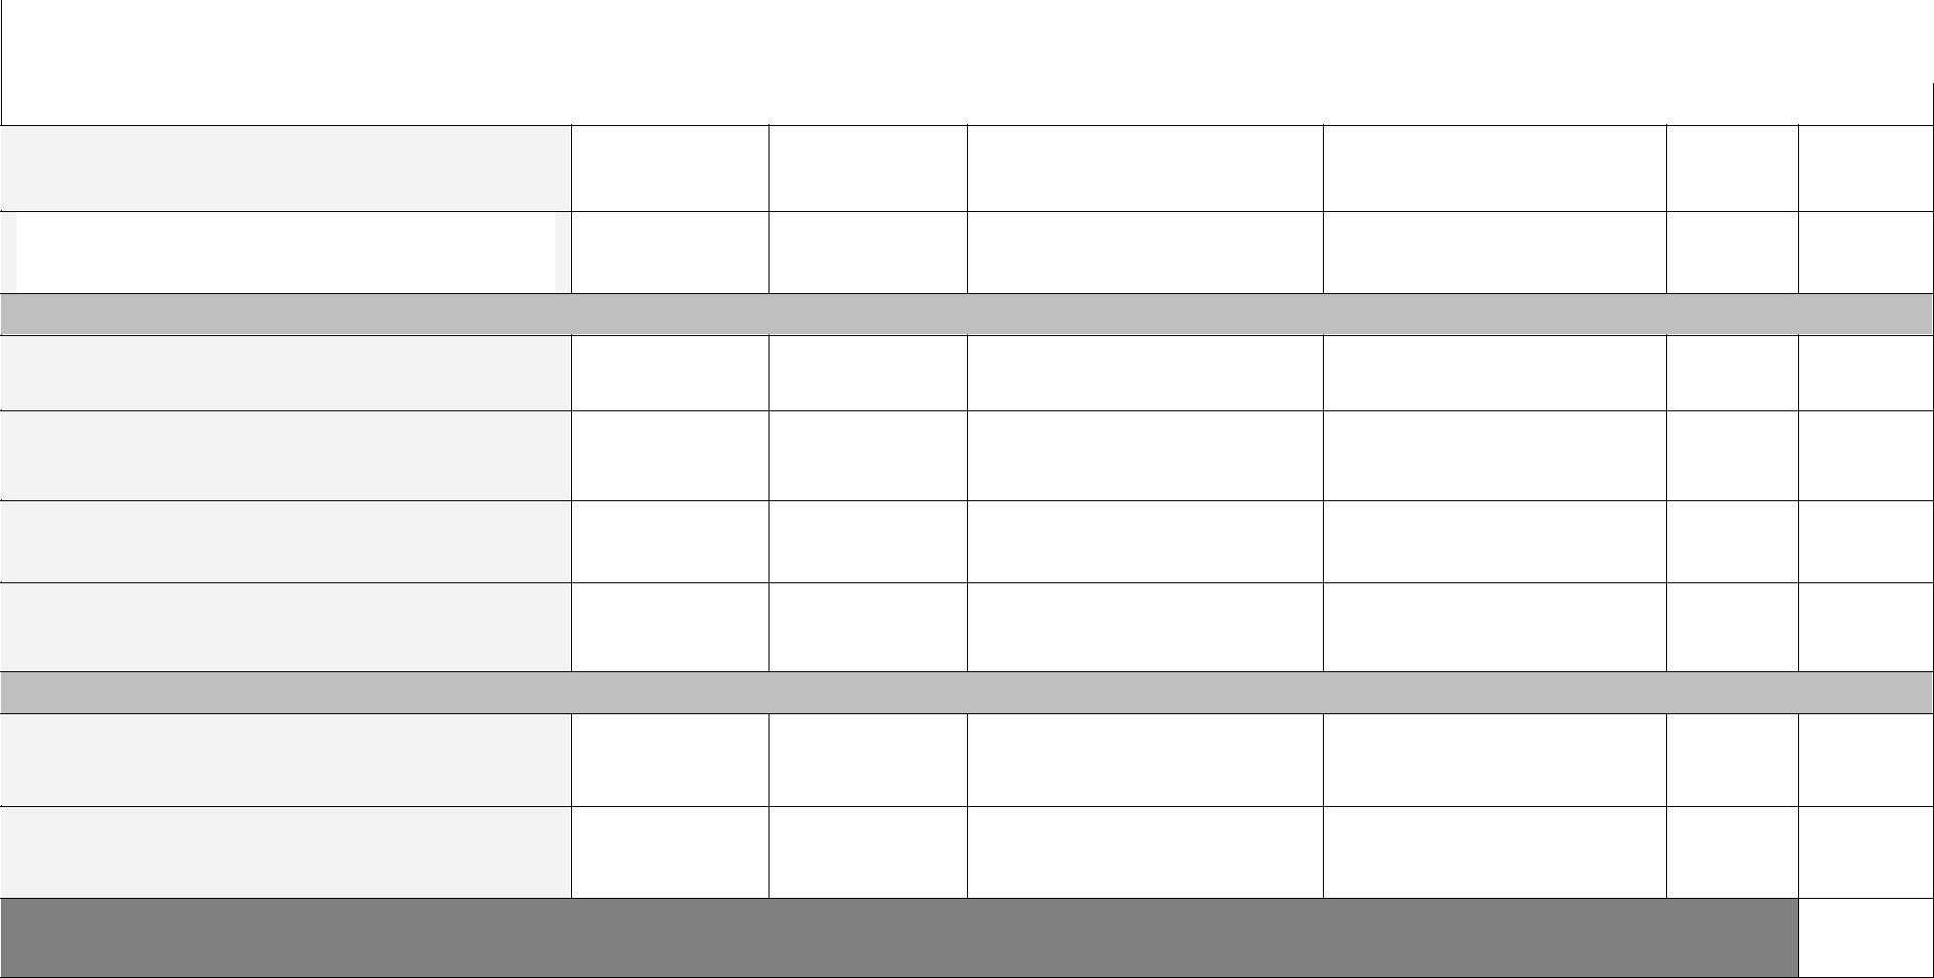

Clear, accurate and thorough

Facts, statistics and/or examples
used to support major points.

Communication

Respectful body language

Respectful responses

Focused/On-topic

Sarcasm avoided

Participation

Full participation

Attentive listening

Total Points (32 pts.)

Comments:

