Working the Problem
Breaking Even: System of linear equations:

Determining the Break-even point

(1) Total expenses per month (y₁) can be expressed by the equation

y₁ = 4x + 900

where x represents the number of hanging baskets purchased.

(2) Selling the hanging baskets (y₂) can be expressed by the equation

y₂ = 16x

(3) Solve for x when y₁ = y₂
4x + 900 = 16x
900 = 12x
75 = x

Using the calculator

Graph the equations y₁ and y₂

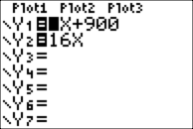

Set WINDOW

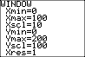

GRAPH

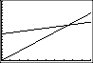

TRACE {to intersection}

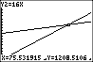

If you are unable to determine the intersection you can change the window by

ZOOM ∨ 8 ⬇ Z Integer ENTER ENTER

TRACE to intersection

The intersection can also be calculated using

2nd TRACE ∨ 5: intersect

The intersection can also be found on a table by using
2nd GRAPH {by scrolling up or down until y₁ = y₂}
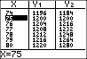

What information can the business owner learn from this table when x = 100?

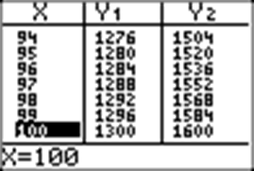

Elaborate / Activity/Application/ Student Engagement /Laboratory
How can this problem be applied in an agricultural setting?

How many baskets do I need to sell to reach a target goal?

What can I do to alter my expenses?

What can I do to improve my profit?

Evaluation / Summary

