Name______________________________________ Date______________________________________
Diplomatic Relations and War History Activity
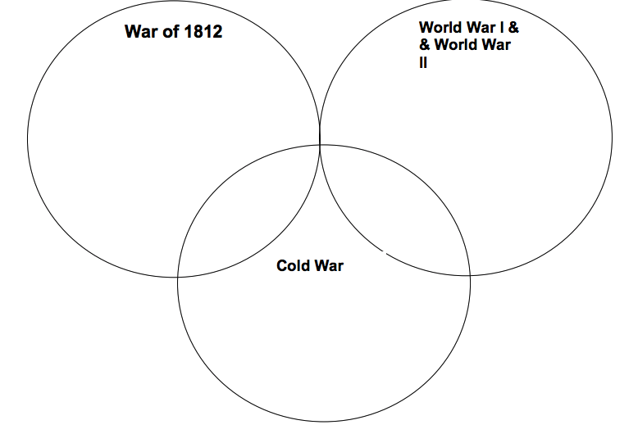
Directions: Research each section regarding American interests during the war. What were the reasons that the US entered the war?

