Inductive Reactance Exam Answer Key
Match the terms with their correct definitions.

1. | Resistance | C | A Opposition to current caused by voltage or current changes not resulting in energy dissipation
2. | Impedance | D | B The rate of change of cyclical motion
3. | Reactance | A | C Opposition to current resulting in energy dissipation
4. | Inductive reactance | E | D Opposition to current including both resistance and reactance
5. | Angular velocity | B | E Circuit opposition caused by inductance

Match the terms with their correct definitions.

6. | Power | E | A The product of volts and amperes in an AC circuit
7. | Reactive power | C | B The ratio of true power to apparent power in an AC circuit
8. | Apparent power | A | C The product of reactive voltage and amperes in an AC circuit
9. | Power factor | B | D The angle that the current leads or lags the voltage in an AC circuit
10. Phase angle |  | D | E The rate of energy consumption in a circuit

Match the symbols with their correct definitions.
11. | XL | E | A Impedance
12. | VARS | D | B Frequency in hertz
13. | Z | A | C Angular velocity in radians per second
14. | f | B | D Reactive apparent power
15. | ω | C | E Inductive reactance in ohms

Match the symbols with their correct definitions
16. | X | B | A Radians in one cycle
17. | PF | C | B | Reactance in ohms
18. | R | D | C | Power factor
19. | 2π | A | D | Resistance in ohms

- Which of the following is not a factor used to compute inductive reactance?

A 2π - reactive apparent power
B ω - angular velocity

C L - inductance
D f - frequency

- Which of the following statements is false concerning current and voltage relationships in RL circuits?
A Current lags voltage by 90º in a pure inductive circuit
B Current and voltage are in phase in a pure inductive circuit
C Current and voltage are in phase in a pure resistive circuit
D Current lags voltage between 0º and 90º in an RL circuit, depending upon relative amounts of R and L present and frequency of applied voltage or current

- Which of the following statements is true concerning the formula for computing inductive reactance?
A ω L
B 2π f L
C Both of the above
D Neither of the above

- Which of the following statements is true concerning inductive time constants?

A In the RL circuit connected to DC, the current immediately rises to the Ohm’s law value when switch is closed
B The time required for current to reach maximum value varies inversely with inductance in henries
C One-time constant equals L/R
D One-time constant equals X_{L} / R

24. Which of the following statements is false concerning inductive time constants?

A The time required for current to reach maximum value varies inversely with resistance in ohms
B During each time constant, the current rises (or fails) 63.2 percent of the value remaining
C During each time constant, the current rises (or falls) 36.8 percent of the value remaining
D During the universal time constant, voltage acts inversely to current

Match the numbered label to the lettered blank on a universal time constant chart.
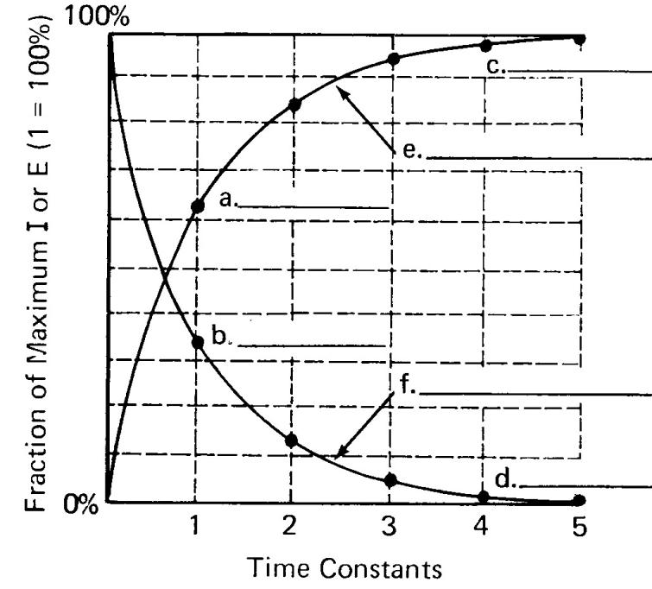

25. | 98.2 | C
26. | 63.2 | A
27. | Inductor current rising | E
28. | 36.8 | B
29. | 1.8 | D

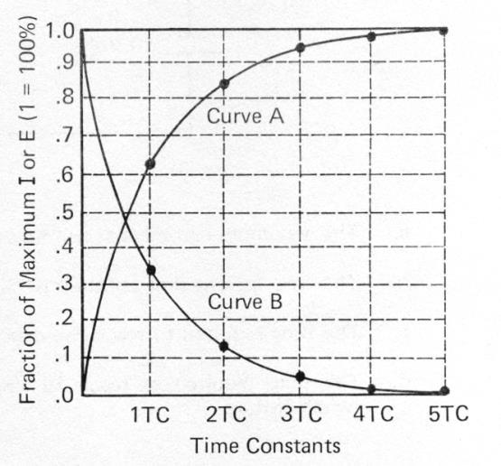

Answer the following questions using the Universal Time Constant Chart above.

- What is the percentage for curve A, at 2TC?
A 95%
B 5%

C 86.5%
D 13.5%

- What is the percentage for curve B, at 2TC?
A 95%
B 5%
C 86.5%
D 13.5%

- What is the percentage for curve B, at 4TC?
A 98%

B 2%
C 100%
D 0%

27. What is the percentage for curve B, at 1TC
A 36.8%
B 63.2%
C 50%
D 86.5%

28. Curve A of the universal time constant chart is called which of the following?
A rising curve

B inductor current rising
C capacitor voltage
D all of the above

