Name _____________________________________ Class: _______ Date: ___/___/___

Inductive Reactance Exam

Match the terms with their correct definitions.

1. | Resistance | A Opposition to current caused by voltage or current changes not
 |  | resulting in energy dissipation.
2. | Impedance | B The rate of change of cyclical motion.
3. | Reactance | C Opposition to current resulting in energy dissipation.
4. | Inductive reactance | D Opposition to current including both resistance and reactance.
5. | Angular velocity | E Circuit opposition caused by inductance.

Match the terms with their correct definitions.

6. | Power | A The product of volts and amperes in an AC circuit.
7. | Reactive power | B The ratio of true power to apparent power in an AC circuit.
8. | Apparent power | C The product of reactive voltage and amperes in an AC circuit.
9. | Power factor | D The angle that the current leads or lags the voltage in an  AC circuit.
10. Phase angle |  | E The rate of energy consumption in a circuit.

Match the symbols with their correct definitions.
11. | XL | A Impedance
12. | VARS | B Frequency in hertz
13. | Z | C Angular velocity in radians per second
14. | f | D Reactive apparent power
15. | ω | E Inductive reactance in ohms

Match the symbols with their correct definitions
16. | X | A Radians in one cycle
17. | PF | B | Reactance in ohms
18. | R | C | Power factor
19. | 2π | D Resistance in ohms

- Which of the following is not a factor used to compute inductive reactance?

A 2π - reactive apparent power

B ω - angular velocity

C L – inductance

D f - frequency

- Which of the following statements is false concerning current and voltage relationships in RL circuits?

A Current lags voltage by 90º in a pure inductive circuit.

B Current and voltage are in phase in a pure inductive circuit.

C Current and voltage are in phase in a pure resistive circuit.

D Current lags voltage between 0º and 90º in an RL circuit, depending upon relative amounts of R and L present and frequency of applied voltage or current.

- Which of the following statements is true concerning the formula for computing inductive reactance?

A ω L

B 2π f L

C Both of the above

D None of the above

- Which of the following statements is true concerning inductive time constants?

A n the RL circuit connected to DC, the current immediately rises to the Ohm’s law value when switch is closed.

B The time required for current to reach maximum value varies inversely with inductance in
henries.

C One-time constant equals L/R.

D One-time constant equals XL / R.

- Which of the following statements is false concerning inductive time constants?

A The time required for current to reach maximum value varies inversely with resistance in ohms.

B During each time constant, the current rises (or fails) 63.2 percent of the value remaining.

C During each time constant, the current rises (or falls) 36.8 percent of the value remaining.

D During the universal time constant, voltage acts inversely to current.

Match the indicated value to the lettered blank on the universal time constant chart.

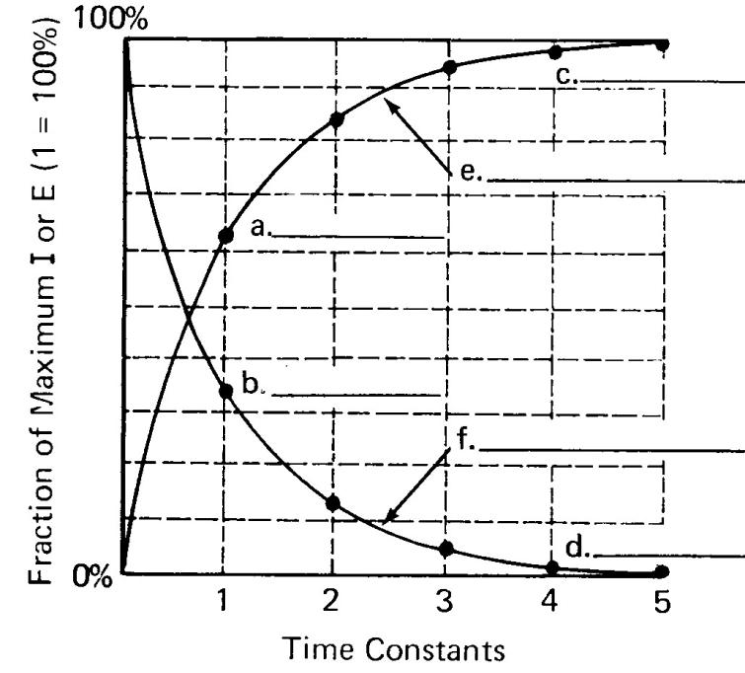

- 98.2

- 63.2

- Inductor current rising

- 36.8

- 1.8

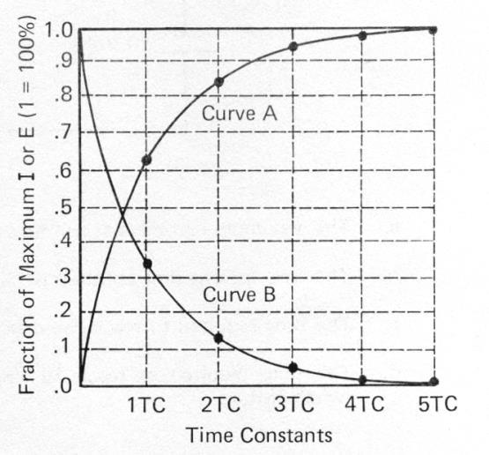

- What is the percentage for curve A, at 2TC?
A 95%
B 5%

C 86.5%
D 13.5%

- What is the percentage for curve B, at 2TC?
A 95%
B 5%

C 86.5%
D 13.5%

- What is the percentage for curve B, at 4TC?
A 98%

B 2%
C 100%
D 0%

- What is the percentage for curve B, at 1TC?
A 36.8%

B 63.2%
C 50%
D 86.5%

- Curve A of the universal time constant chart is called which of the following?
A rising curve

B inductor current rising
C capacitor voltage
D all of the above

