Name _____________________________________ Class: _______ Date: ___/___/___

Inductive Reactance Written Exam

- State three formulas for determining true power.

  - _____________________________

  - _____________________________

  - _____________________________

- State three formulas for determining apparent power.

  - _____________________________

  - _____________________________

  - _____________________________

- State three formulas for determining reactive power.

  - _____________________________

  - _____________________________

  - _____________________________

- State four formulas for determining power factor.

  - _____________________________

  - _____________________________

  - _____________________________

  - _____________________________

- State the formula for determining quality factor (Q) or figure of merit of an inductor.

- Compute the applied voltage and impedance in a series RL circuit in which the voltage across the resistor is 50 volts, the voltage across the inductor is 120 volts, and the current is 13 milliamps.

  - Applied voltage is ______ volts
  - Impedance is ________ ohms.

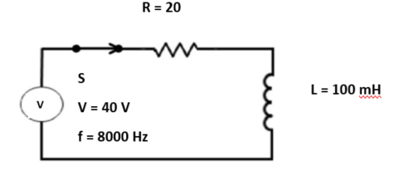

- From the figure above, find:

- XL =__________ = _________ = _________
- Z =__________ =__________ = _________
- VR =__________ = _________ = _________
- VL =__________ = __________ = ________

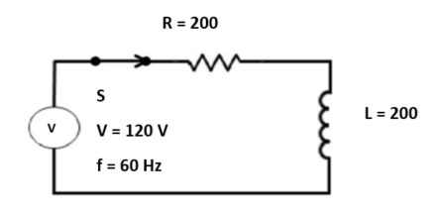

- From the figure above, find:
a. X_{L} =__________ = _________ = _________
b. Z =__________ = _________ = _________
- I =__________ = _________ = _________

- VR = __________ = _________ = _________

- VL = __________ = _________ = _________

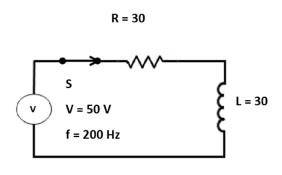

- From the figure above, find:
  - XLT =__________ = _________ = __________

  - Z = __________ = _________ = __________

  - I = __________ = _________ = __________

  - VL = __________ = _________ = __________

e. θ = __________

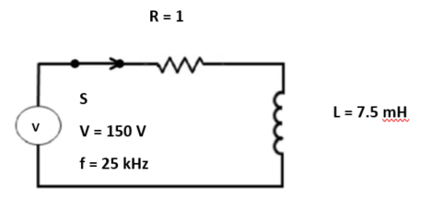

- From the figure above, find:
  - XLT =__________ = __________ = __________

  - Z = __________ = _________ = __________

  - I = __________ = __________ = __________

  - VL = __________ = __________ = __________

  - θ = __________

