Name _____________________________________ Class: _______ Date: ___/___/___

Inductive Reactance

Lab Activity # 1 - Show the Effect of Inductance in AC Circuits

Tools and Materials

- Filter choke approximately 2h or larger
• 75 ohm, 1 watt resistor |  |  | R
• | DC and AC milliammeter |  | ^{S}1
• | Multimeter | V_{S} | L
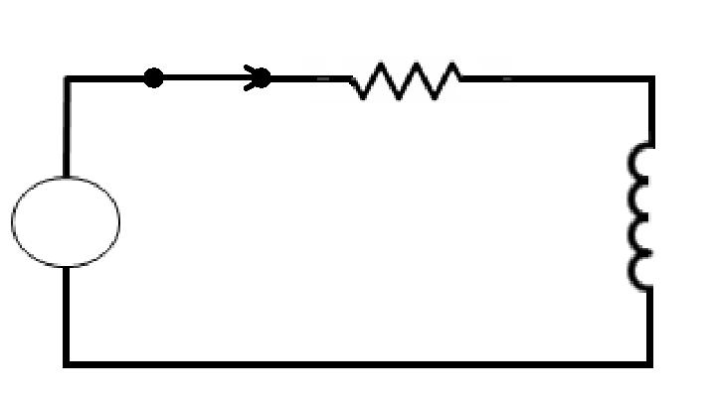

- AC and DC power supplies

Procedure

- Connect the 75 ohm resistor and DC ammeter in series with the DC power supply without the inductor (for now).

- Adjust the voltage until there are 5 volts across the resistor.

- Record the ammeter indication _____________; then compute RDC
(NOTE: RDC = V/I).

- Connect the 75 ohm resistor and AC ammeter in series with the AC power supply.

- Adjust the voltage until there are 5 volts across the resistor; then record the current from the ammeter______________ and compute RAC (NOTE: RAC = V/I).

- Compare R_{DC} and R_{AC} and explain differences noted, if any.

- Connect the filter choke (inductor) and DC ammeter in series with the DC power supply as shown.

- Adjust the DC power supply until there are 5 volts across the resistor; read the current indication on the ammeter __________ and compute ZL(DC) (NOTE: Z L (DC) = EL/IL.).

- Repeat Step 8 using the AC ammeter and AC power supply and compute ZL(AC) (NOTE: ZL(AC) = VL/IL).

- Compare the current recorded in Step 8 with that recorded in Step 9, and explain any differences noted.

- Use the filter choke value (in henries) and the voltage frequency to compute XL.

- Compare the computed XL (Step 11) with the DC impedance (Step 8) and with the AC impedance (Step 9).

- Explain any differences noted.

- Turn off circuit, disconnect components, and place materials in the proper storage area.

