Name _____________________________________ Class: _______ Date: ___/___/___

Inductive Reactance

Lab Activity Sheet # 2 - Solve for Values of an Operating RL Circuit

Tools and Materials

- Filter choke approximately 2h or larger

- Resistor, 750 ohms, 5 watts

- AC milliammeter

- Multimeter

- AC power supply, 60 Hz

- Switch

Procedure

- Measure and record the resistance of the inductor (filter choke) with your ohmmeter (NOTE: This is the DC resistance (RDC) of the coil). _______

- Measure and record the actual value of the 750-ohm resistor. __________

- Connect the circuit as shown in the following schematic (Figure 1).
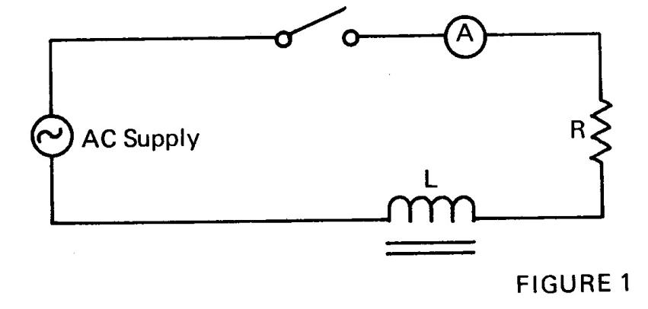

- Connect an AC voltmeter across the AC power supply, close the switch, and adjust the AC input until the meter indicates 10 volts.

- Read and record the voltage across R (VR). _____________________

- Read and record the voltage across L (VL). _____________________

- Read and record the applied voltage (across both R and L). _________

- Read and record the current flowing in the circuit (I). ____________

- Compute the value of XL. __________________________________

- Add the coil’s DC resistance (Step 1) and the resistor value (Step 2), and then multiply this value by the circuit current and compare the result with the applied voltage (EA) observed in Step 7.

- Arithmetically add VR (Step 5) and VL (Step 6), and then compare with VA (Step 7) (V_{est} = V_{R} + V_{L}).

- Repeat (Step 11), but use the formula VA = √ VR² + VL² . Compare Vest to VA.

- Multiply the current (Step 8) and the computed value of XL (Step 9), and then compare the result with VL (Step 6).

- Make a vector diagram to scale (Figure 2) showing the values of V_{R},V_{L}, and V_{A}, letting V_{A} be the hypotenuse of the right triangle formed by sides V_{R} and V_{L}; explain any differences noted.
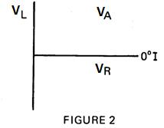

- Discuss and explain differences observed with your teacher.

- Turn off power, disconnect tools and material, and place in the proper storage area.

