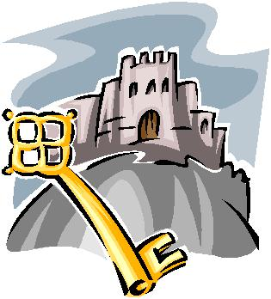

Egg Catapult

Scenario:

You are one of the Knights of the Round Table. King Arthur has just given you the task of redesigning a portion of the Castle’s defenses system. You must design a catapult system that can clear the castle’s wall from the greatest possible distance.

Assignment:

Your challenge is to design and construct a device that will catapult a Grade A Large egg (mortar) over a 1- meter high wall. You may only set or “cock” the device. You can NOT in any way aid the egg catapult system.

Criteria:

*Materials: You may use ONLY the following items.

2-Soda bottles (1 or 2 liter size) 4’-0” of Tape
1-Egg crate or container 6-Paper clips
4’-0” of String 2-Wire coat hangers
6- Rubber bands 1-Plastic spoon
2-Popsicle sticks

4-Drinking straws

*Design:

Any design will be acceptable as long as it is functional and performs the assigned task safely.

*Testing:

- Get only one round, but you will have 3 attempts to fire your catapult if needed. We will have wooden eggs for you to test fire with.

- Wall height is 1 meter. To get a minimum 70% the catapult must be 1-meter away from the wall. Each meter you increase in distance will raise the grade 5 points. If the egg does not clear the wall, but it does fire it will be 65%.

- Winner will be the team that clears the wall from the farthest distance.

