Name: _________________________ Class: ________________________ Date ___/___/___
Electrical Power

Lab #2 – Determine Power Used in a Resistive Circuit

Equipment and materials

- Adjustable DC power supply (0-30 volts)
- DC wattmeter (0-20 watts)
- 330-ohm, 2-watt resistor
- Ammeter or multimeter
- DC voltmeter and ohmmeter (multimeter)

Procedure Steps

- Leaving the power off, connect the following circuit (Figure 1.) a. FIGURE 1
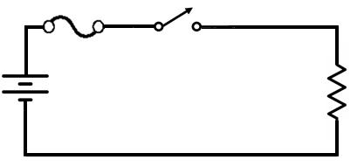

- Double check your circuit for correct wiring.

- Turn on power.

- Apply 10 volts across the resistor.

- Measure the voltage to set it to the indicated value, then measure the current and power and record the values.

 | OBSERVED |  |  | COMPUTED
 | _________________ |  |  | ________________
Data Table | V | I | P | V | I | P
(Record step 5.) | 10 V | ____ | ____ | ____ | ____ | ____
(Record step 7.) | 15 V | ____ | ____ | ____ | ____ | ____
(Record step 9.) | 20 V | ____ | ____ | ____ | ____ | ____
(Record step 12.) | _____Ω

- Increase the power supply to 15 volts.

- Read and record V, I, and P in the Data Table.

- Increase the power supply to 20 volts.

- Read and record V, I, and P in the Data Table.

- Turn off the power supply.

- Disconnect the circuit.

- Read its value with the ohmmeter and record in the Data Table.

- Using the three forms of power formula, compute the power for the V, I, and R values at 10 volts, 15 volts, and 20 volts.

- Compare the computed values with the wattmeter readings.

NOTE: The following questions may be used for discussion:

- What causes the difference between computed values and wattmeter indications?

B. Did the resistance remain constant during this experiment? Did the current remain constant? Compare the changing voltage with the power consumed by the resistor. Is the relationship a direct proportion or inverse proportion?

- Would the same power be consumed if the load were reversed? Why?

- When the voltage was doubled (10 V to 20 V), how much did power increase?

- Return the equipment and materials to the proper storage area.

