Name: ____________________________________ Class: ______________________ Date ___/___/___

Answer Key: Electrical Power

Lab #3 – Determine the Function of Fuses and Resistor Power Rating

(NOTE: The teacher may want to conduct this lab as a demonstration.)

Equipment and materials

- Variable power supply (minimum 10 V, 1-amp capability)
- 1,000-ohm, ½-watt resistor
- 10-ohm, ½-watt resistor (expendable)
- One ½-amp fuse (expendable)
- DC ammeter (1-amp capability)

Procedure

- Connect the power supply, switch, 1,000-ohm resistor, ammeter, and ½-amp fuse in a series as shown in Figure 1.
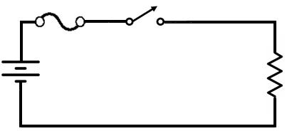

FIGURE 1

- Turn on the power supply.

- Adjust to 10 volts.

- Turn on switch.
10 mA
- Read and record the current indication on the ammeter. ____________

- Turn the power supply to zero.

- Open the switch.

- Replace the 1,000-ohm resistor with the 10-ohm resistor.

(CAUTION: Set range switch, if applicable, to 1 ampere or more)

- Close the switch.
- Adjust the power supply to 10 volts.
- Observe the fuse and record what you observe. The fuse should blow because I = 1 A
- Connect a wire across the fuse and observe the 10-ohm resistor, and record what you observe. The 10 ohm resistor should overheat and burn up without the fuse showing that the fuse protects the circuit.

