Name: _____________________________ Class: _______________Date ___/___/___
Student Activity – Electrical Power
Directions for Compute Power from the Power Formula
Study the following schematics and answer the questions below them. Use the formulas for power:
- P=VI when current and voltage are known;
- P=I²R when current and resistance are known; and

- P=V² /R when voltage and resistance are known.
A.
I = 25 mA
R = 150 Ω

- State the power formula(s) needed to solve for power.
- Solve for P.

B.
R = 100 Ω
R = 250 Ω
V = 16 V
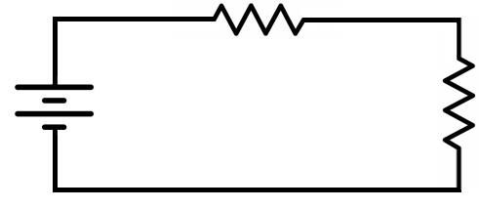

- State the power formula(s) needed to solve for power.
- Solve for P.
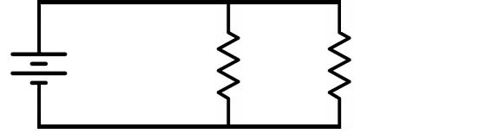
C. | I = 60 mA
I = 20 mA
R = 40 Ω

- State the power formula(s) needed to solve for power.
- Solve for P.

