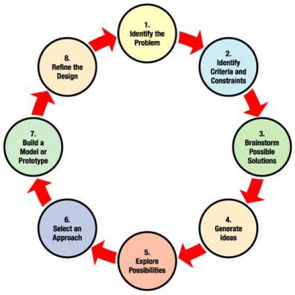
Le

The

Engineering

Design
Process

Team Members Names:

______________________________________________________

Step #1 = Identify the problem

Step #2= Identify Criteria and Constraints

Time Frame = ______________________________________________________
Tools that can be used = _________________________________________________________

Step #3 = Brainstorm Possible Solutions *Thumbnail sketches

Step #4 = Generate Ideas *Thumbnail sketches

Best Idea #2

Best Idea #3

Step #5= Explore Possibilities

Discussion highlights:

_________________________________________________________
_________________________________________________________
_________________________________________________________
_________________________________________________________
_________________________________________________________

My Designs Pros | My Designs Cons

Step #6 = Select an Approach “Which design are you going to use and why?”

Sketch of it:

Step #7 = Build a Model or Prototype to solve the problem given (step #1) based off the Criteria and Constraints given (Step #2) based off the Best Idea you had (Step #6).

Step #8 = Refine the Design

So what worked in your prototype?

What didn’t work in your prototype?

What did your classmates think about your prototype?

What can you change to make it better?

Sketch what changes you are going to make and refine your prototype for the final test.

