Trace Evidence: Hair Unit Exam Key

Part I: True or False (5 pts. each)
- F
- F
- F
- F

Part II: Multiple Choices (5 pts. each)
- C
- D
- B
- C
- B
- A

Part III: Short Answers

- - Pigments
Human hair pigments are consistent throughout the hair.
Animal hair pigments exhibit radical changes.

- Scales
Human hairs have imbricate scales.
Animal hairs can have imbricate, coronal, or spinous scales.

- Medulla
A human hair medulla has a width of less than 1/3 of the shaft diameter and is amorphous.

Animal hair medullae are thick and have distinct patterns. (6 pts.)

- Caucasian hair pigments tend to be fine and light in density.

Negroid hair pigments tend to have moderate size, heavy density, and aggregated clumping.
Mongoloid hair pigments tend to be large, heavily dense, and streaky. (11 pts.)

- Head hairs are typically longer than pubic hairs, and are often seen with artificial treatment.

Pubic hairs are typically coarse and exhibit “buckling.” (4 pts.)

- Because hair characteristics can be influenced by not only the genetics, but also environmental effects such as one’s diet, weather, or artificial treatment. (5 pts.)

- Fill in the blanks. (12 pts.)

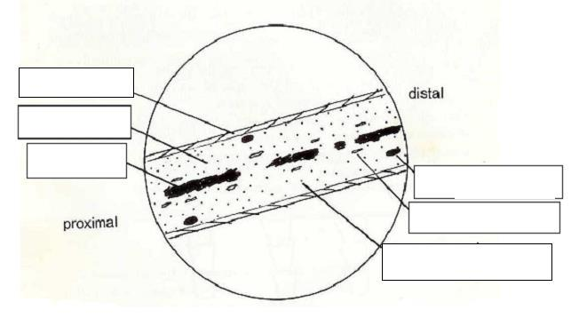

- Bat hair
- Rabbit fur hair
- Caucasian pubic hair
- Deer hair (12 pts.)

