Name:___________________________________ Date:__________________________

Trace Evidence: Hair Unit Exam
Part I: True or False (5 points each)

- Only human hairs have the imbricate scales.

- The gender of a questioned hair can be determined based on microscopic hair examination.

- Ovoid bodies are only seen in animal hairs.

- Different dogs of the same breed can be distinguished if the roots are present.

Part II: Multiple Choices (5 points each)

- What is the protein that makes up the hair shaft?
  - Melanin
  - Pheomelanin
  - Keratin
  - Medulla

- Which one of the following components of hair can be used in nuclear DNA analysis for personal identification?

  - Medulla
  - Scales
  - Cortex
  - Follicular tag

- Which one of the following growth stages typically has the largest amount of pigments?
  - Catagen
  - Anagen
  - Telogen
  - Postmortem

- Which one of the following growth stages typically has the most amount of cortical fusi?
  - Catagen
  - Anagen
  - Telogen
  - Postmortem

- Flat cross-sections are typically seen in hairs.

  - Mongoloid
  - Negroid
  - Caucasian
  - Animal

- Forensic human hair comparisons are only performed on
a. Head and pubic hairs
b. Head and facial hairs
c. Facial and pubic hairs
d. Facial, head, and pubic hairs

Part III: Short Answers

11) List and describe the three main differences between human and animal hairs. (6 pts.)

12) Describe the differences in pigments between the three racial groups. Be sure to include the differences in pigment size, density, and any special characteristics. (11 pts.)

13) Describe how one can distinguish the difference between head and pubic hairs. (4 pts.)

- Explain why hair evidence can be used to distinguish between a set of identical twins when nuclear DNA analysis cannot. (5 pts.)

15) Fill in the blanks. (12 pts.)
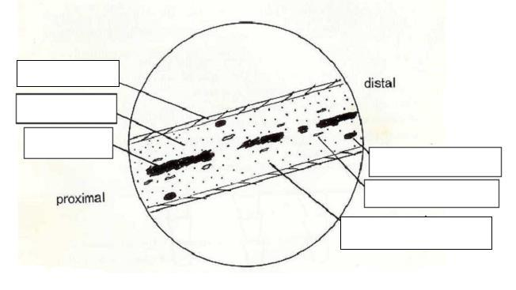

16) Identify the origin for each of the following pictures using the list below. (12 pts.)

Caucasian head hair Rabbit fur hair Bat hair

Deer hair Caucasian pubic hair Dog hair

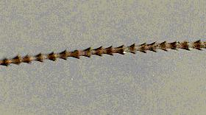
a.

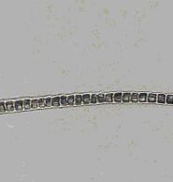
b.

c.
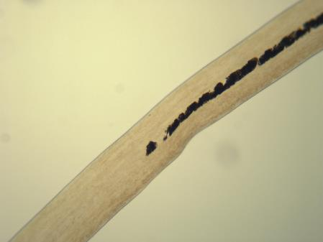

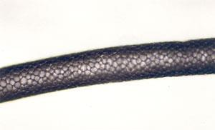
d.

