Oral Presentation Rubric: Songs for Advertising Decades
Extension Activity #1
Student Name: _____________________________________________________
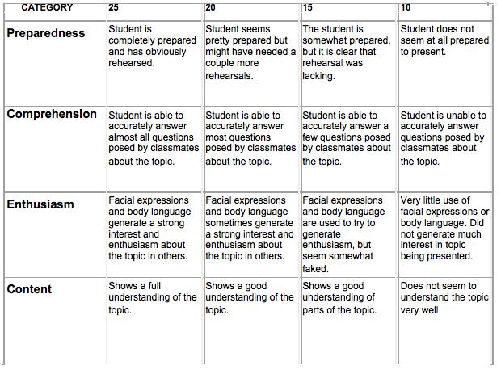
Total Score _________
Maximum 100 Points

