Famous Business Leaders Venn Diagram

I. To familiarize students with business leaders, students will research three different business leaders. They can use any search engine or library database for “famous business leaders” or any other phrase that generates detailed results. They may also use the following website: http://www.hbs.edu/leadership/database/. They will select three leaders, read about their biographies, their qualities, and their accomplishments, and record three leadership characteristics for each leader in each of the three circles of the Venn diagram. In the middle section, which overlaps all three circles, the students will record any characteristics that are common to all three leaders. If any characteristics are similar only to two leaders, they can be listed in the section that overlaps the two circles for those two leaders.

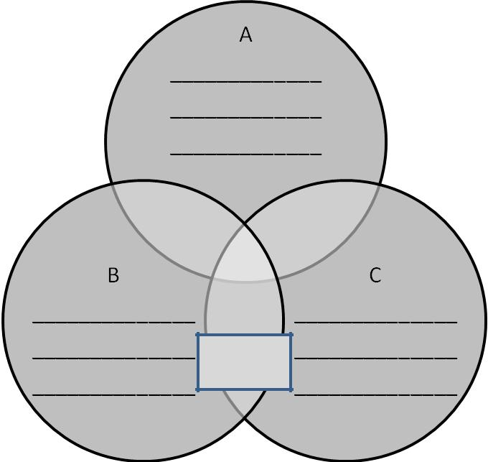

similar |  |  |  | similar
to A & B |  |  |  | to A & C
 |  | similar
 |  | to all

similar
to B & C

- After the diagram is completed, write or type a summary paragraph that describes which one of the three leaders above you would prefer to have worked for. Explain why, based on that leaders’ qualities and what you know about yourself and the type of leadership skills that you would prefer in a leader of your team.

