Find Me: All About the Internet

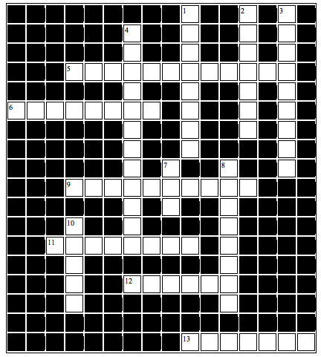

Across

- A program that searches the web for specified keywords and return hits (2 Words)
- Type these in search engines to get information
- A suffix at the end of a URL that specifies program
- A social network used by friends and family on the Internet
- Popular search engine that switches its homepage on holidays
- Was used to do research before the invention of the Internet

Down
- The main page of a web site. Pops up when you first start your Internet browser
- Newer web browser
- A picture or text that links to another place on the Internet of document
- WWW
- An organization or enterprise that proves access to the Internet
- Started with ARPAnet by the government: A collection of electronic networks of computers
- A popular search engine. Name is like a milk drink

