Name: ____________________________________________________ Date: _______________________

First Aid Demonstration Checklist

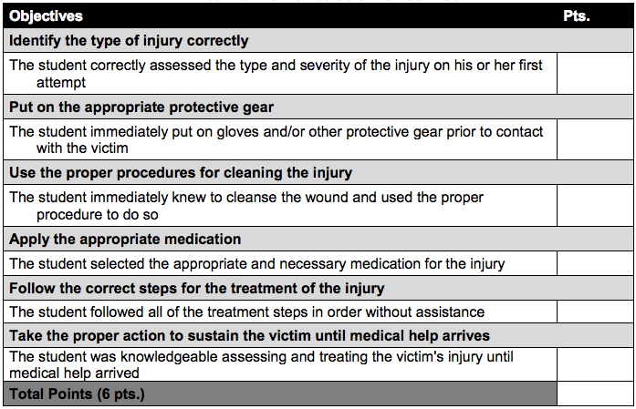

Comments:

