Name_______________________________________ Date__________________
Bone Review Crossword Puzzle
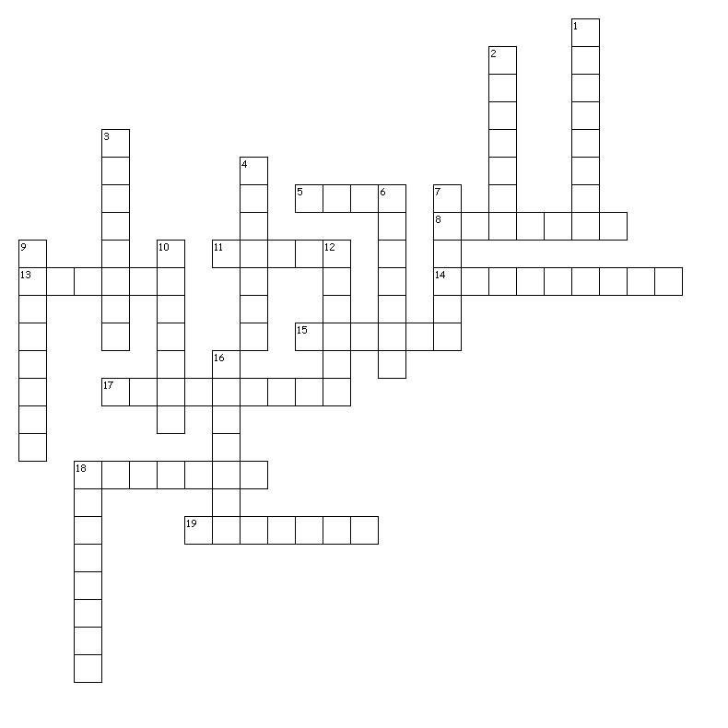

Across  5. protect the lungs  8. shoulder blade  11. single upper leg bone  13. large vertebrae of lower back  14. very back of the skull  15. smaller bone of the lower leg  17. toes and fingers  18. support most of the weight of the foot  19. wrist bones | Down  1. small vertebrae of the neck  2. kneecap  3. lower jaw bone  4. it's not funny when you hit this bone  6. breastbone  7. hip bones  9. collarbone  10. bone of the forehead of the skull  12. one of the lateral bones of the upper limb  16. upper bone of mouth/jaw  18. vertebrae of the chest area

Bone Review Crossword Puzzle Key

Across:

- Ribs – protect the lungs
- Scapula – shoulder blade
- Femur – single upper leg bone
- Lumbar – large vertebrae of lower back
- Occipital – very back of the skull
- Fibula – smaller bone of the lower leg
- Phalanges – toes and fingers
- Tarsals – support most of the weight of the foot
- Carpals – wrist bones

Down:

- Cervical – small vertebrae of the neck
- Patella – kneecap
- Mandible – lower jaw bone
- Humerus – it's not funny when you hit this bone
- Sternum – breastbone
- Oscoxa – hip bones
- Clavicle – collarbone
- Frontal – bone of the forehead of the skull
- Radius – one of the lateral bones of the upper limb
- Maxilla – upper bone of mouth/jaw
- Thoracic – vertebrae of the chest area

