Name____________________________________ Date________________________

Forensic Entomology Lab

Rationale:
This activity allows students to observe an insect’s life cycle on decomposing flesh.
Materials/equipment needed:
Chicken or beef liver (cut up)
Plastic containers with ventilated lids
Magnifying glass or stereoscopic microscope with petri dish

Forceps
Procedure:
- Label your container with your class period and group number.

- Obtain a piece of liver and put it in the container. Do not put on the lid.

- Place the container outdoors and move away so flies can “find the corpse” and lay eggs on it.

- After at least 30 minutes, return to the area and retrieve your container.

- Cover it with the ventilated lid and store it in an area free from excessive draft or cold temperatures.

- Observe and record what you see with the “Crime Scene Sample.”

- Observe and record the data of your container daily for two weeks.

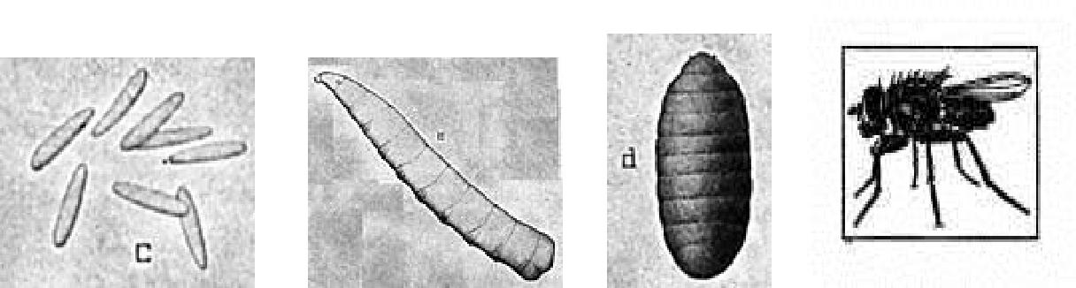

Day | Stage of Insect Found | Appearance and Condition of Corpse | Odor Detected | Other Characteristics (Location of insects, etc.)
1
2
3
4
5
6
7
8
9
10
11
12
13
14

Crime Scene Sample Observation

______________________________________________________________________

______________________________________________________________________

______________________________________________________________________

______________________________________________________________________

DATA TABLE FOR “CORPSE” OBSERVATION

- Describe the observations that you expected to have with this activity. Anything unexpected?

- What conditions could affect this data?

- Approximately how many “days old” was the crime scene sample? How did you determine this?

Forensic Entomology Lab Key

- Answers will vary

- Temperature, rainy conditions, excessive wind, other predators in the area

- To be determined by the teacher.

